Records

Logistics Case Study

IVF6ILV

Integrated Value Flows

**Created on:** 03 March 2025

**Author:** Fabian Zaiser

Table of Contents

SD Challenge 3

Task 3

Datasheet 3

Process steps 3

Step 1: Create .... 3

Step 2: Create .... 3

PP Challenge 4

Task 4

Datasheet 4

Process steps 4

Step 1: Create .... 4

Step 2: Create .... 4

MM Challenge 5

Task 5

Datasheet 5

Process steps 5

Step 1: Create .... 5

Step 2: Create .... 5

Logistics Case Study 6

Task 6

Datasheet 6

Process steps 6

Step 1: Create .... 6

Step 2: Create .... 6

# SD Challenge

## Task

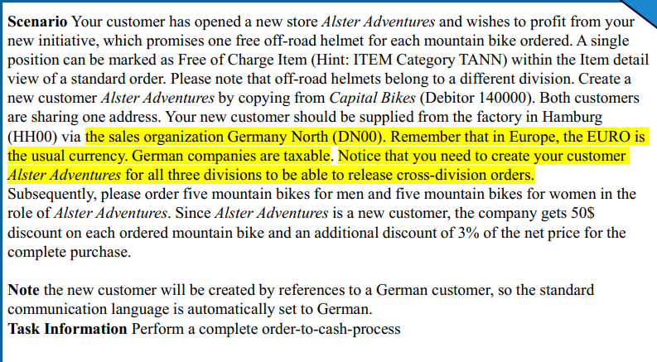

## Datasheet

|  |  |  |
| --- | --- | --- |
| Type (Organizational Data  /Master Data/Transaction Data) | Data | Number |
| Master Data | Business Partner (Customer) | 1003422 |
| Transaction Data | Sales Order | 220 |
| Transaction Data | Outbound Delivery | 80000088 |
| Transaction Data | invoice | 90000087 |
| Transaction Data | Journal Entry | 90000009 |
|  |  |  |
|  |  |  |
|  |  |  |

## Process steps

### Step 1: Create Alster Adventures S25 014

Created it by copying from Capital Bikes 140001, Berlin location

Customer Number: 1003422

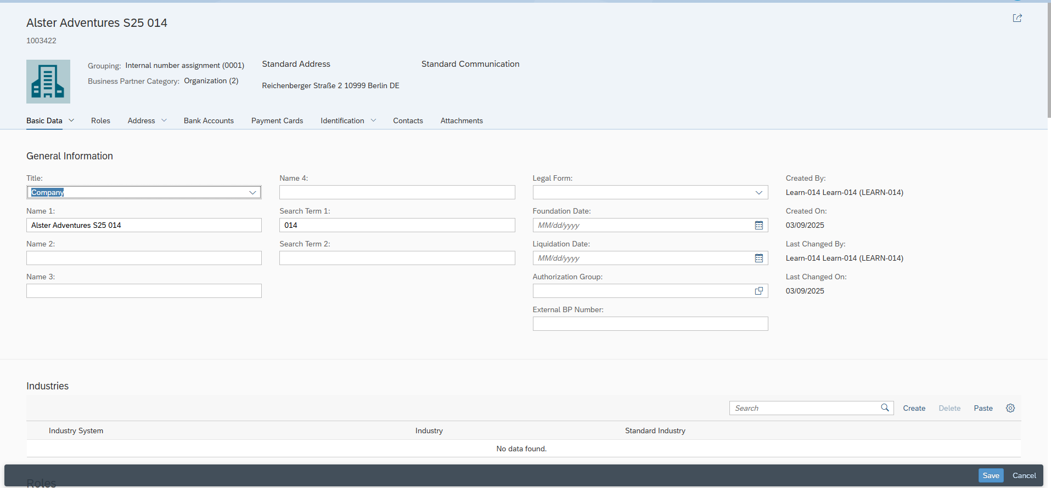–

We can see here by copying from capital bikes, we also have the DN00 Wholesales BI division which is needed later.   
Note: We only have 2 divisions but the task description SD challenge states we need to create it for all three divisions, which right now is not clear to me what this means.

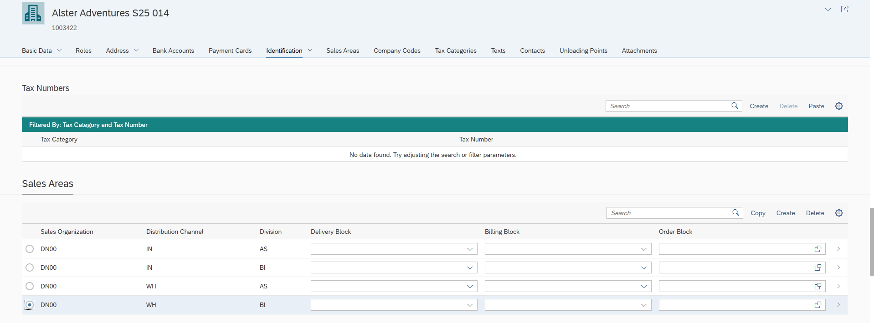

### Step 2: Create Standard Order Part 1

Description & Screenshots

Standard Order

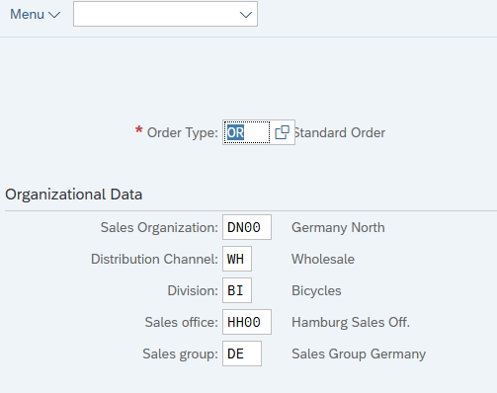

....

### Step 3: Create Standard order Part 2

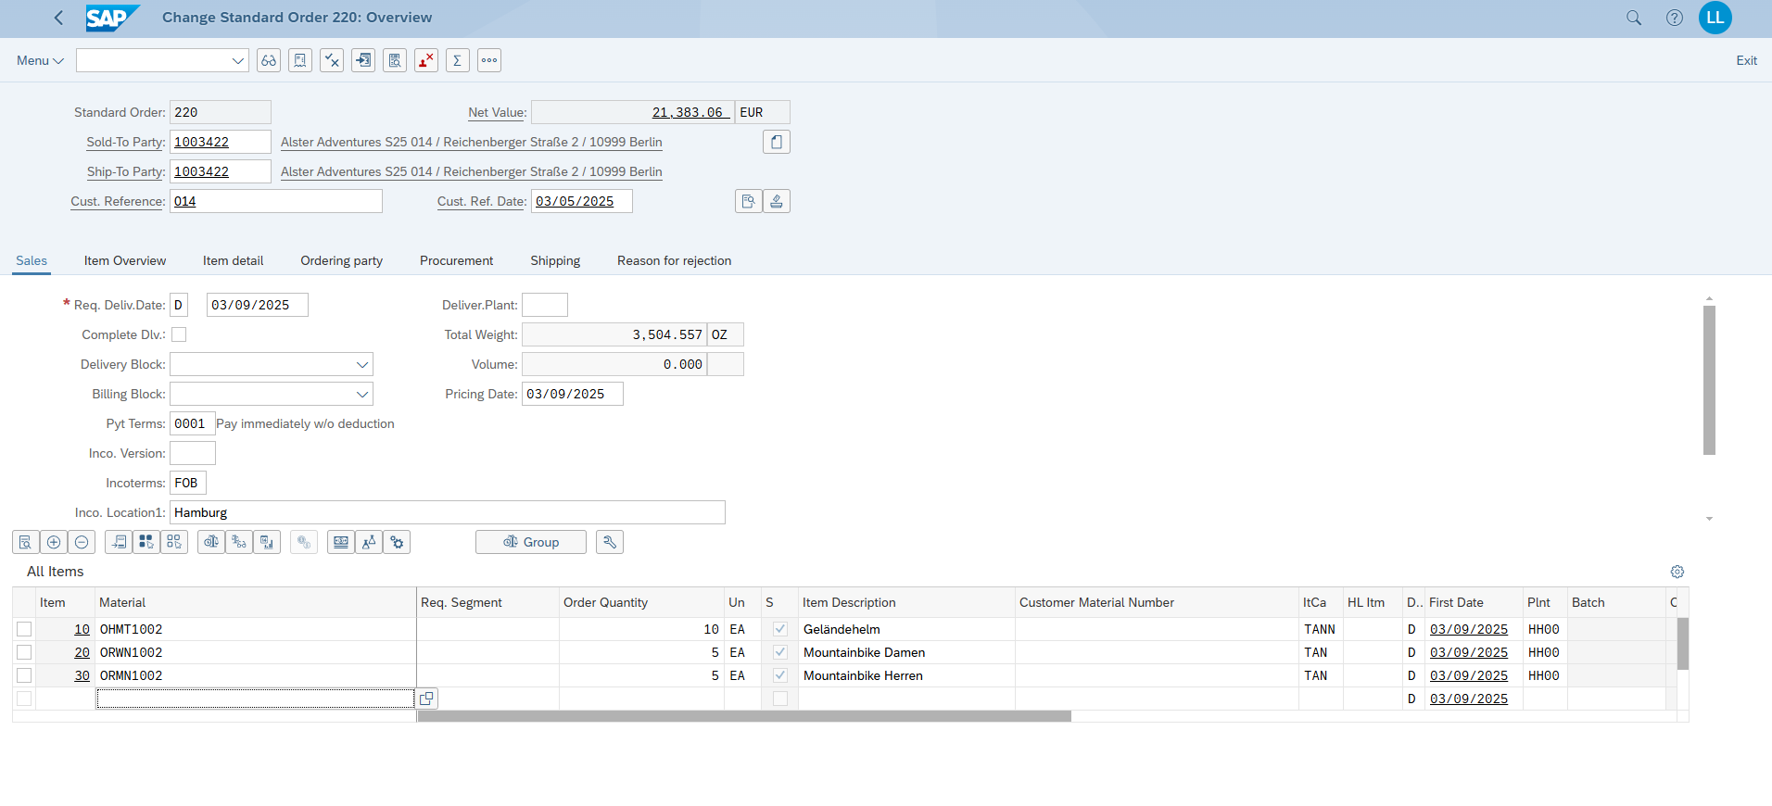

### Step 4: Details about pricing conditions

Women Bikes

RA00 Discount from Net : 3%

RC00 Quantity Discount: -50€ (this is per bike so 250 total)

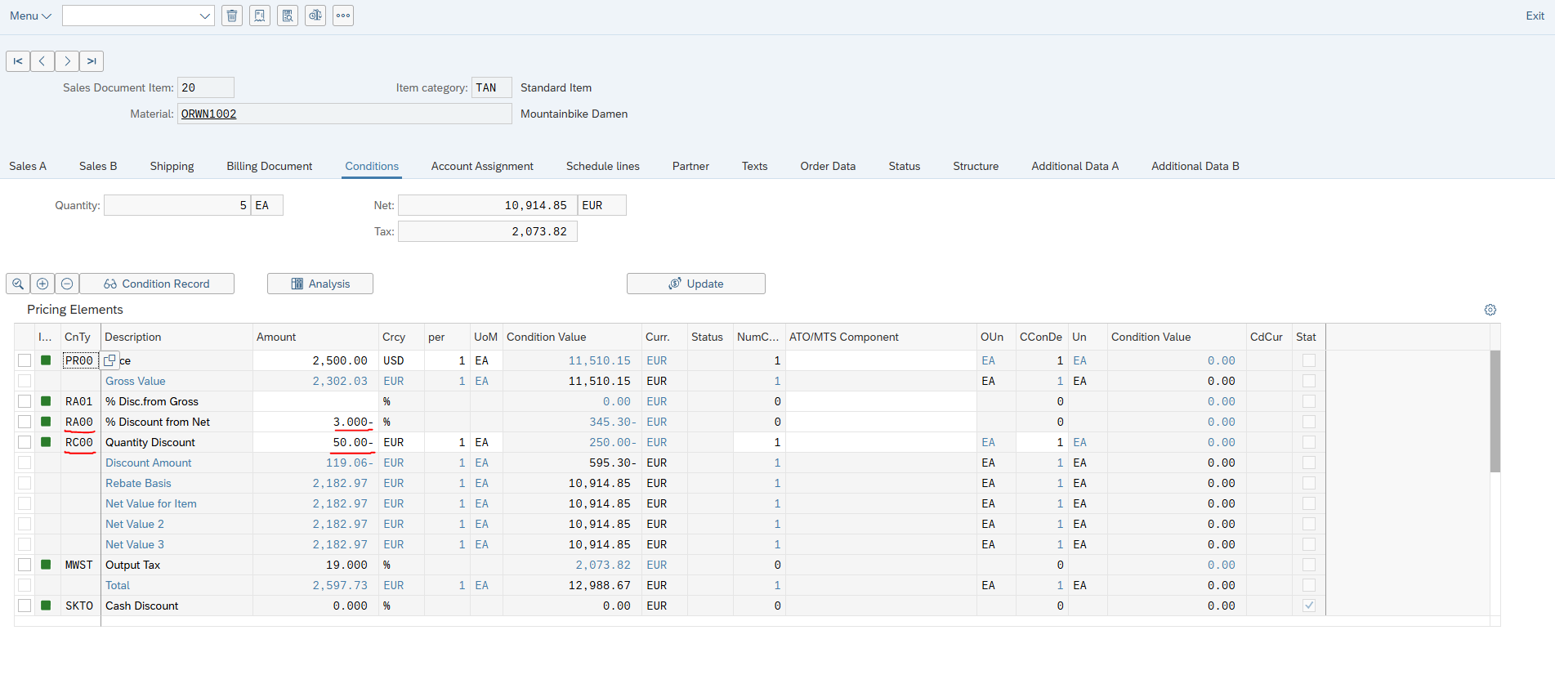

Men Bikes (same as Women above)

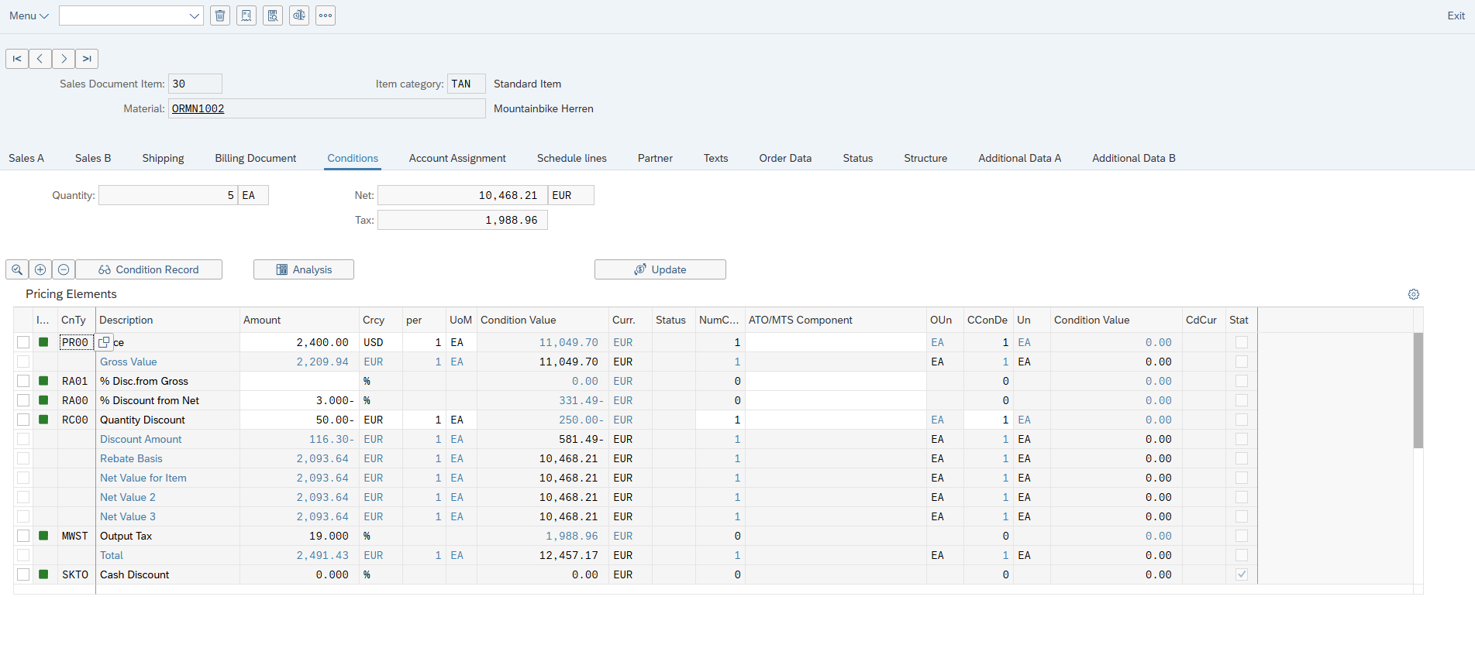

### Step 5: Finish Sales Order



### Step 6: Track Sales Order

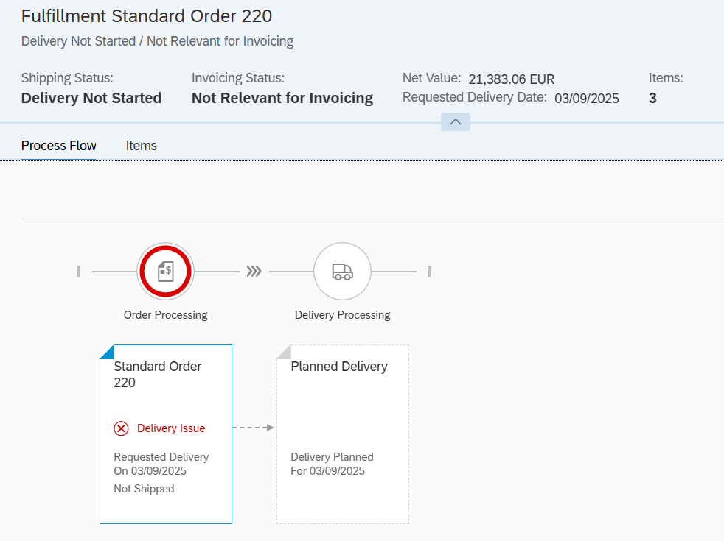

### Create Outbound Delivery

Used sales document: 220 -> pressed button <create deliveries>

### Manage Outbound deliveries

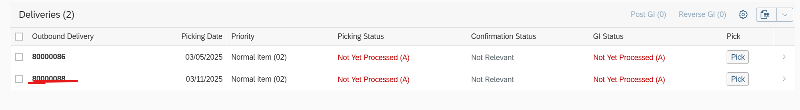

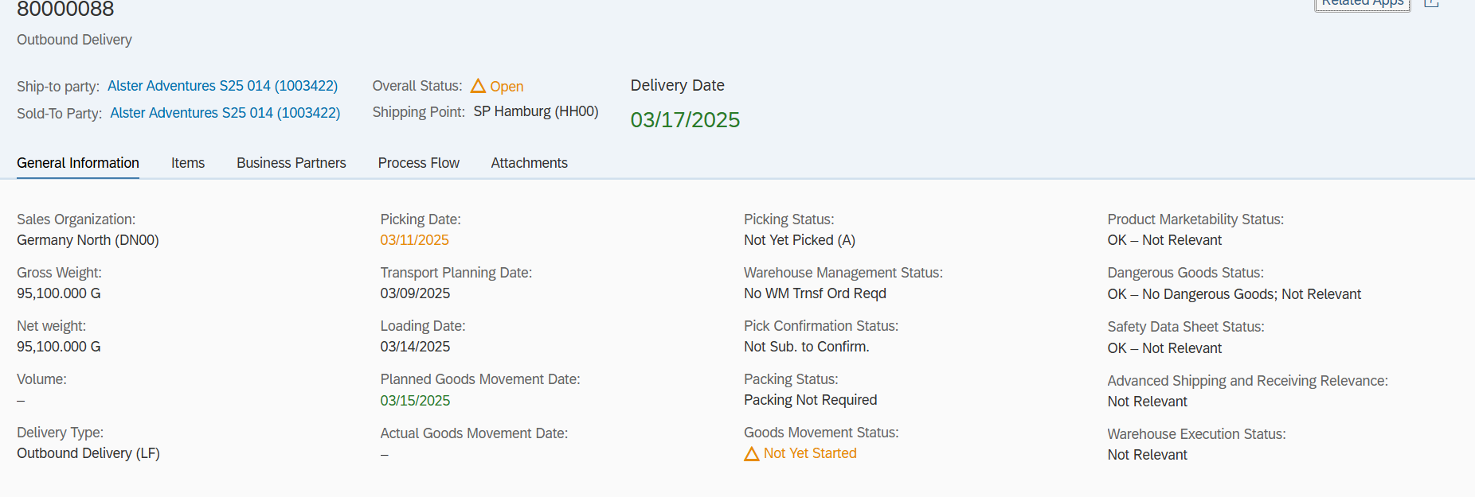

### Outbound Delivery Saved

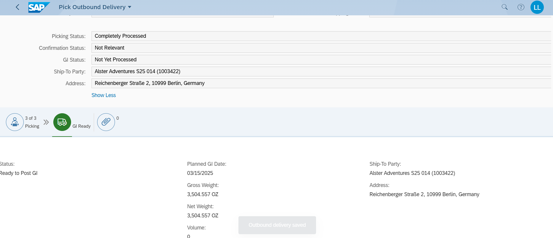

### Pick Outbound Delivery

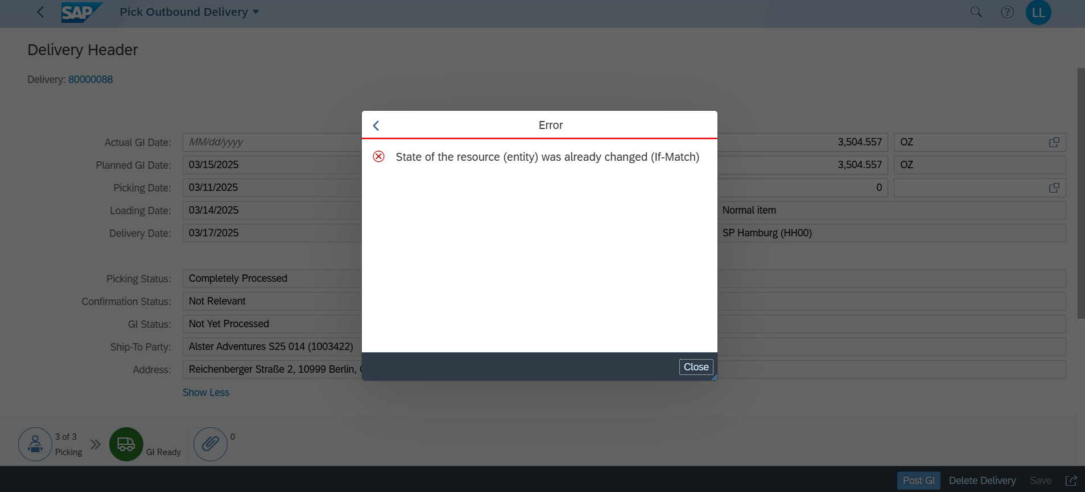

### Goods picked & POST GI was successful

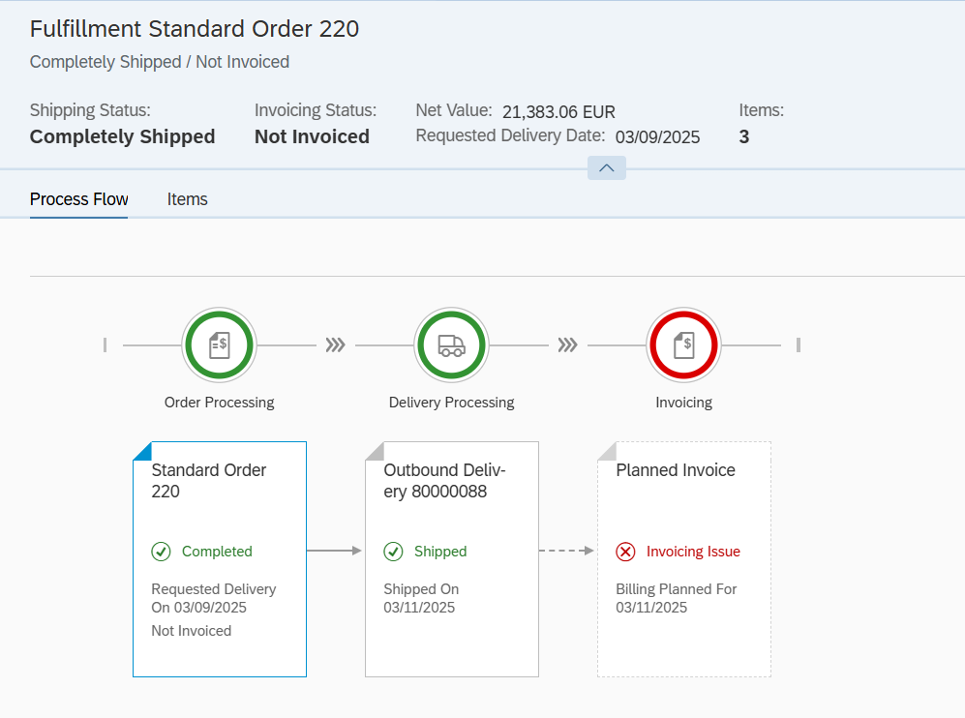

### Create Billing Document

Sales Document: 80000088

### Manage Billing Document

Here we can overview the correct state.

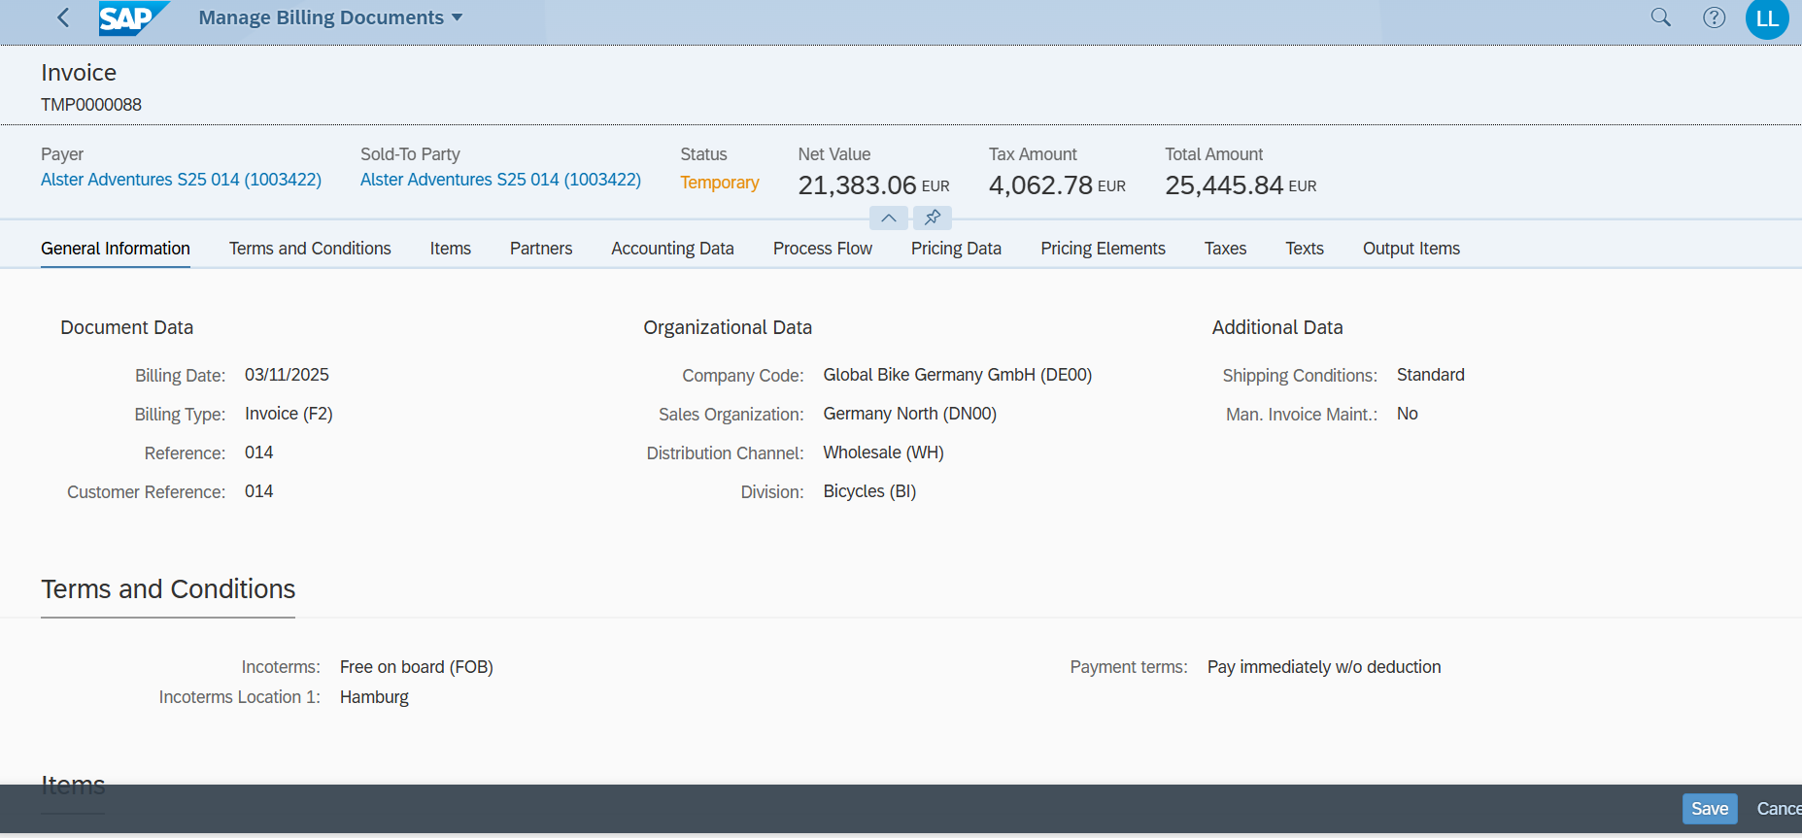

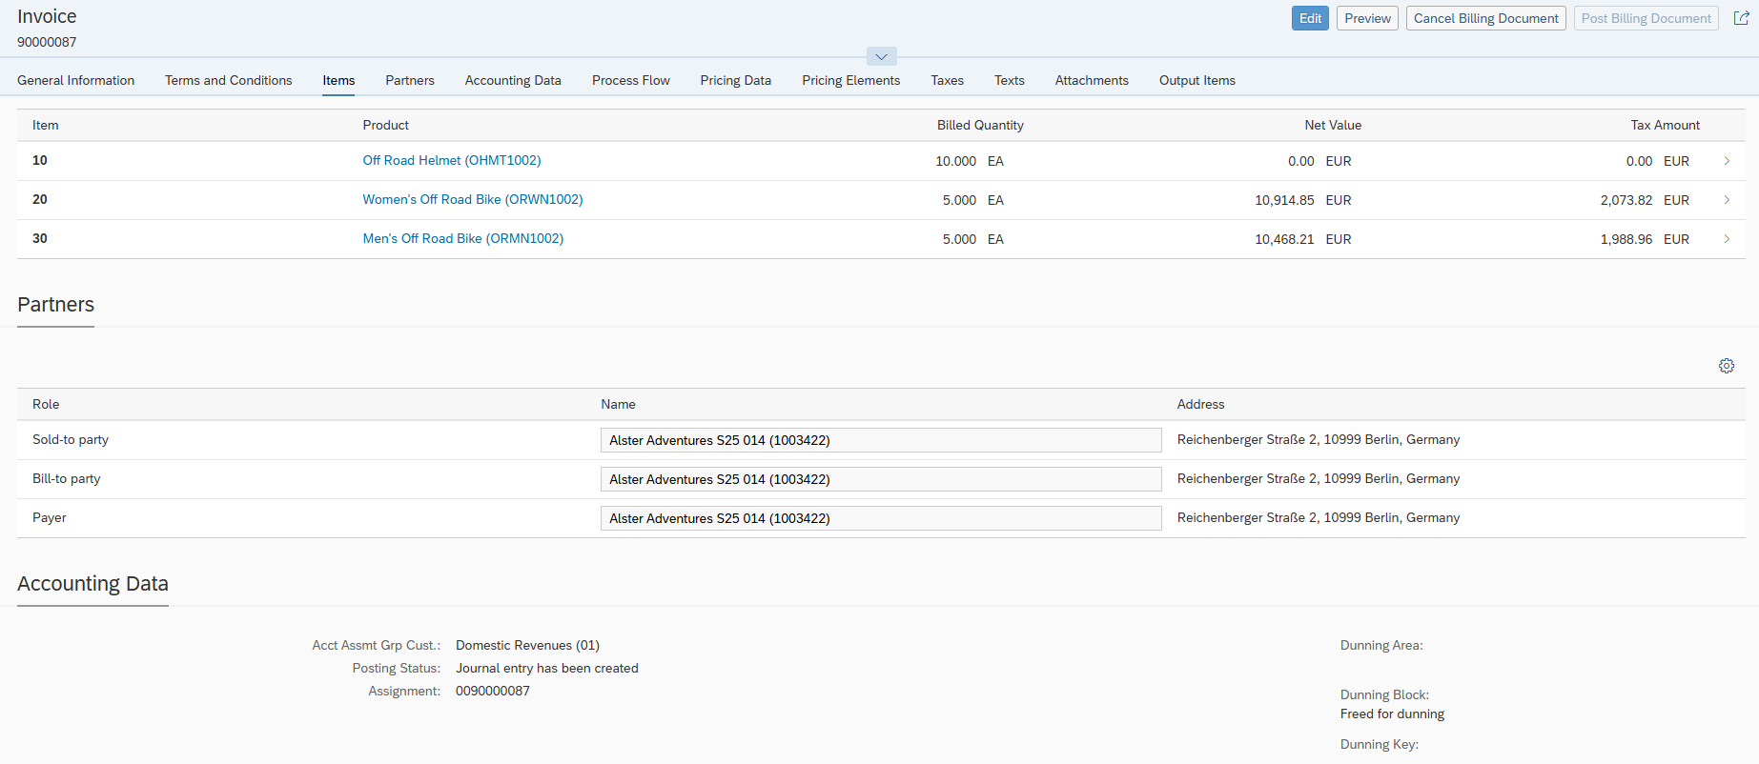

### Process Flow Overview

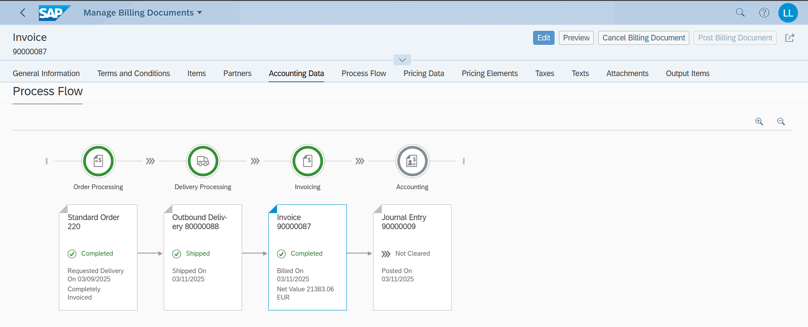

# PP Challenge

I am part of Group 1 – therefore not Challenge here.

## Task

## Datasheet

|  |  |  |
| --- | --- | --- |
| Type (Organizational Data  /Master Data/Transaction Data) | Data | Number |
|  |  |  |
|  |  |  |
|  |  |  |
|  |  |  |
|  |  |  |
|  |  |  |
|  |  |  |
|  |  |  |

## Process steps

### Step 1: Create ....

Description & Screenshots

### Step 2: Create ....

Description & Screenshots

### Step 3: Create ....

Description & Screenshots

### Step 4: Create ....

Description & Screenshots

### Step 5: Create ....

Description & Screenshots

### Step 6: Create ....

Description & Screenshots

# MM Challenge

## Task

## Datasheet

|  |  |  |
| --- | --- | --- |
| Type (Organizational Data  /Master Data/Transaction Data) | Data | Number |
| Master Data | Customer (Business Partner) | 1003453 |
| Transaction Data | Purchase Info Record (Bolt1014) | 5300000517 |
| Transaction Data | Purchase Info Record (TRTR1014) | 5300000522 |
| Transaction Data | Purchase Info Record (TRWH1014) | 5300000524 |
| Transaction Data | Purchase Requisition | 10001300 |
| Transaction Data | Purchase Order | 4500000190 |
| Transaction Data | Material Document | 5000000351/2025 |

## Process steps

### Step 1: Create Business Partner

Description & Screenshots

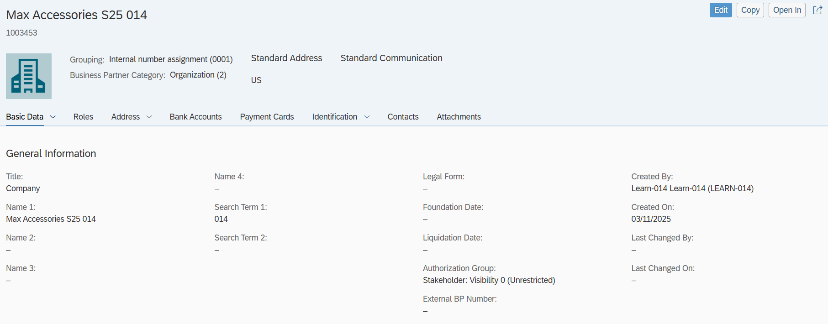

Roles

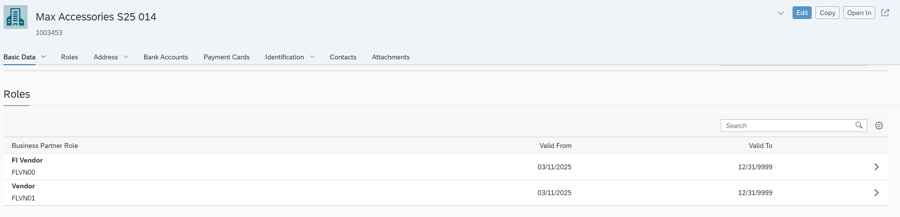

For the Vendor Roles, here we see the PO & CC

Purchasing Organisation:

Within it we also set USD currency & Payment immediately due

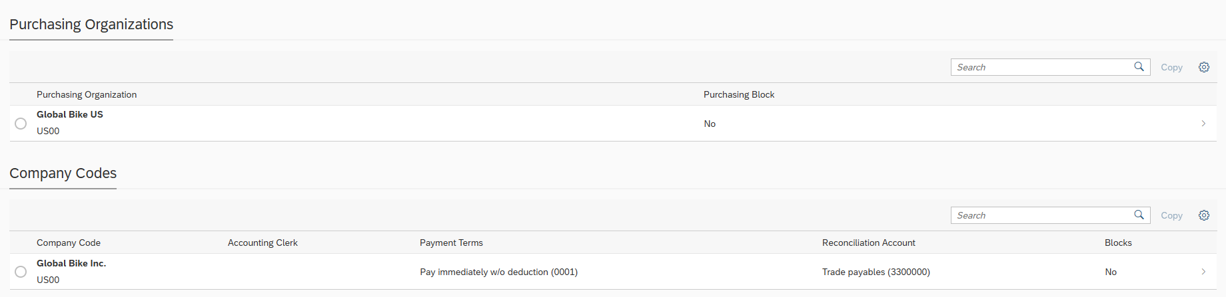

### Step 2 : Create purchasing info record

For all three materials the process is the same. You choose e.g. material name, price in conditions, delivery quantity etc.

Bolt:

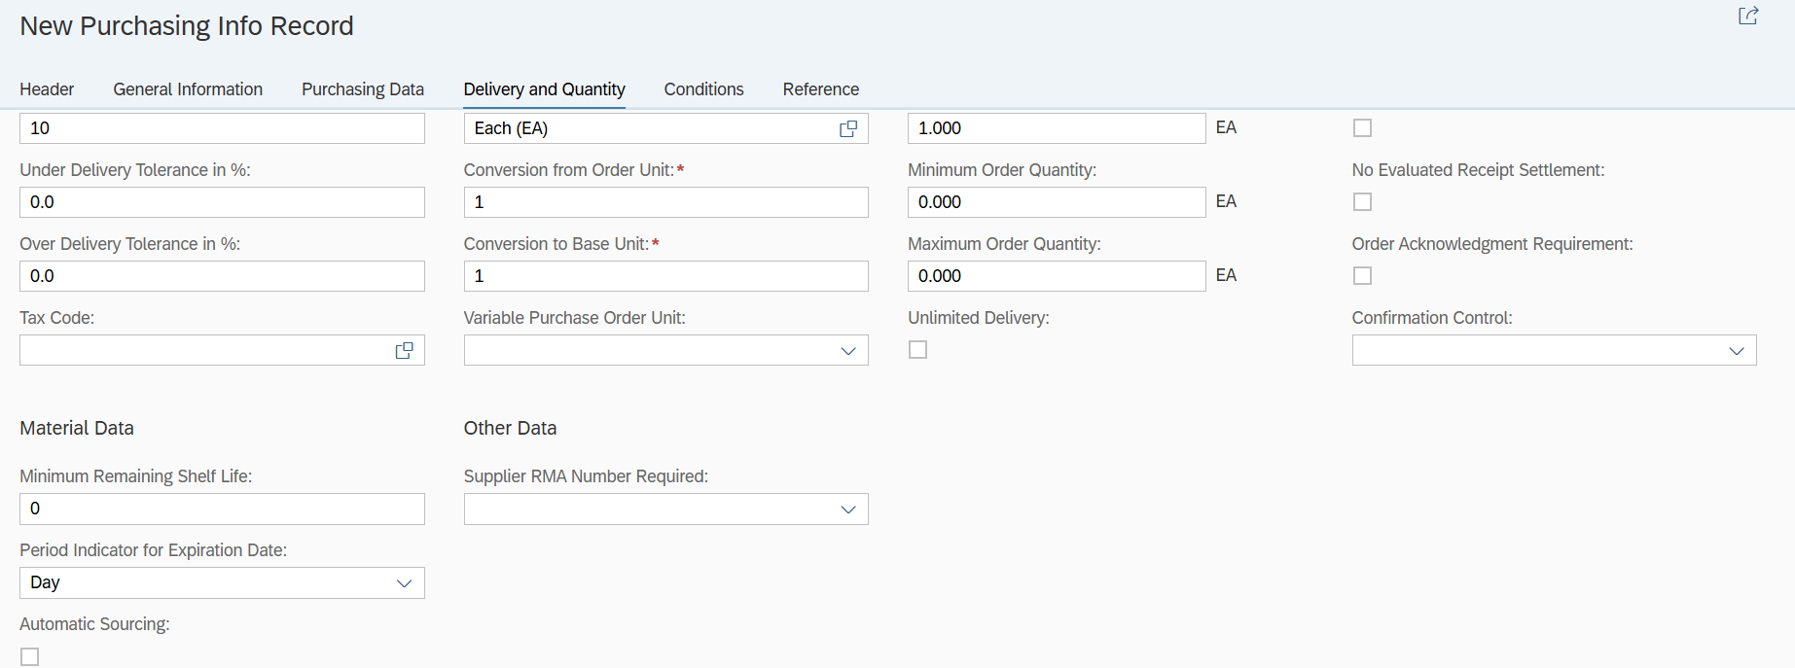

Created (Bolt)

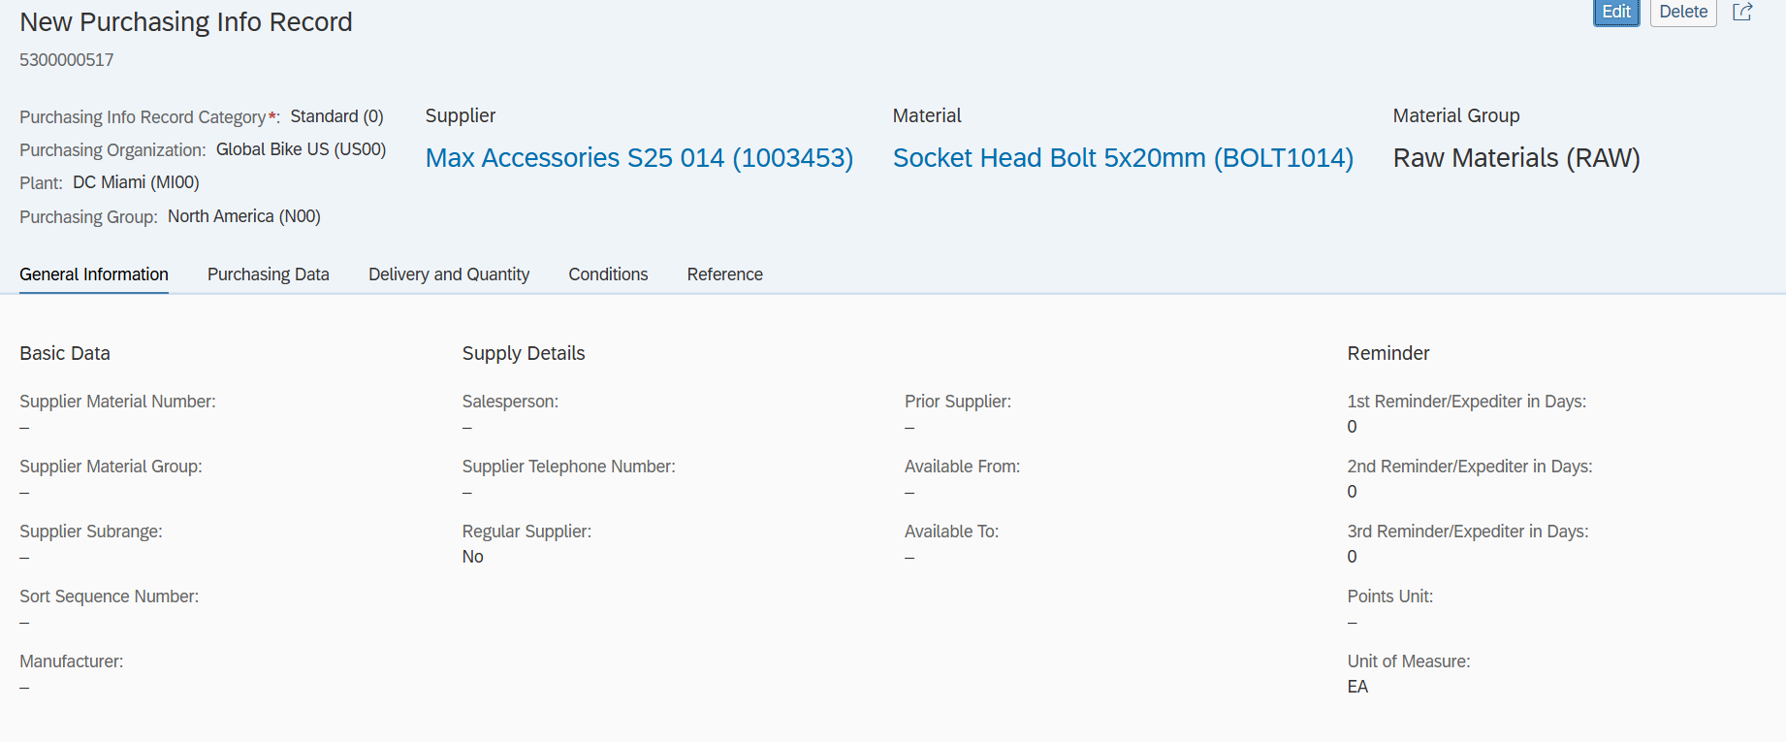

Completion of all 3 materials purchase info records

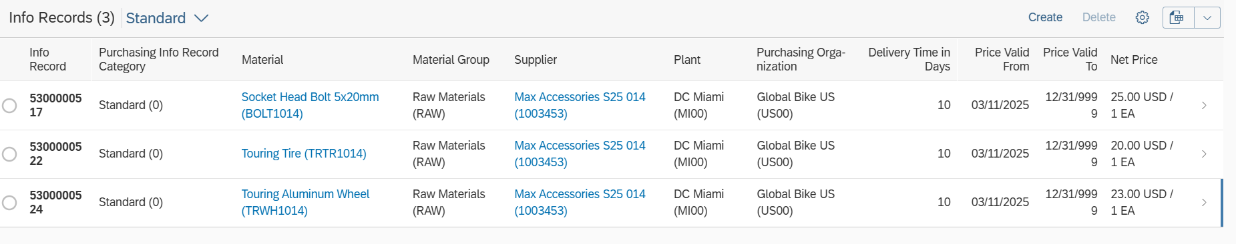

### Step 3: Create Purchase Requisition

All steps are the same for all 3 materials.

Bolt:

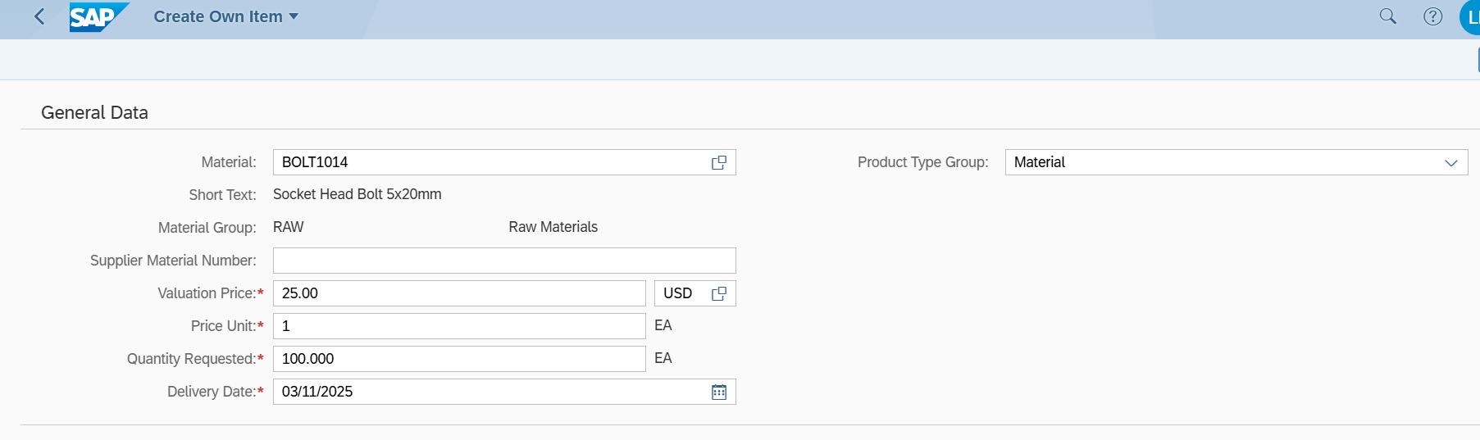

Same steps for Tire & Wheel.

Material Order

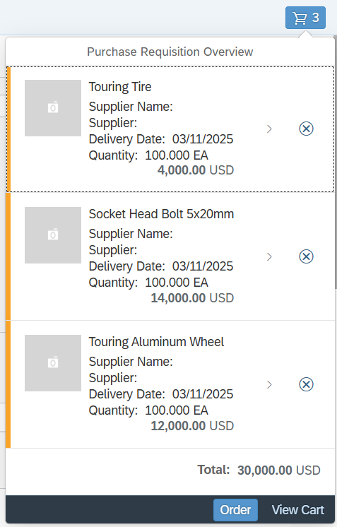

### Step 4: Create purchase order

Bolt:

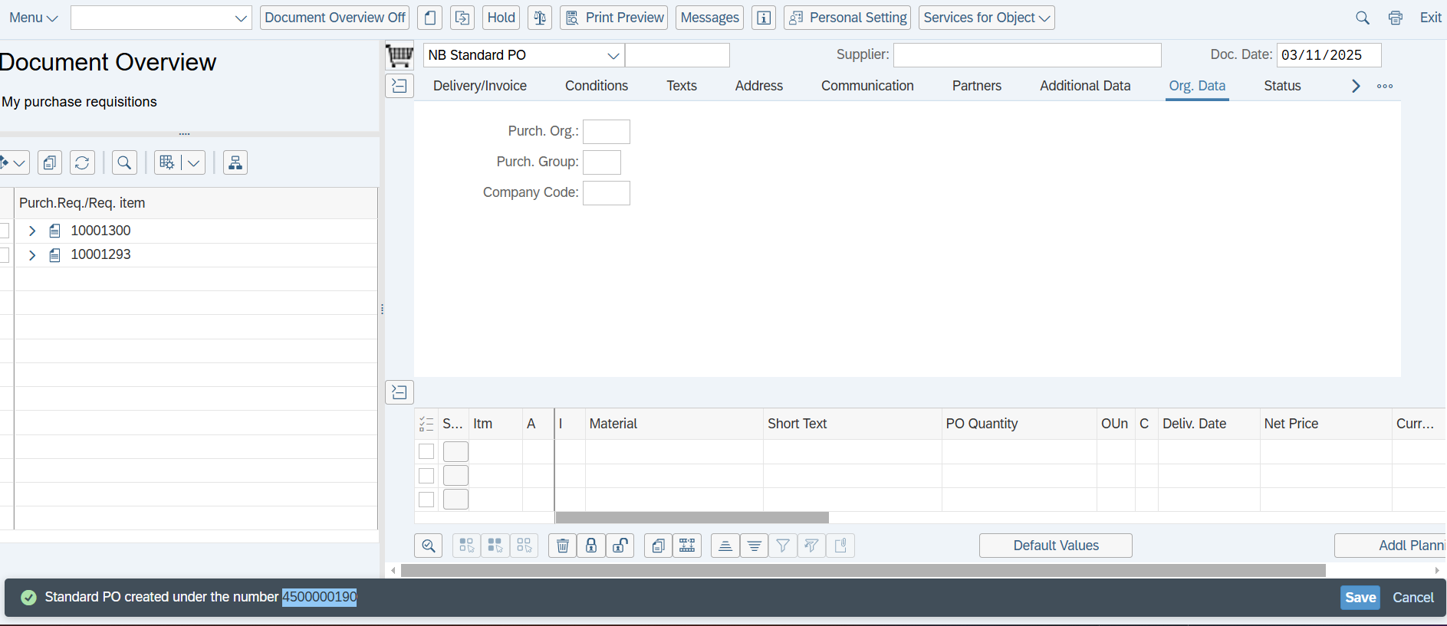

### Step 5: post goods receipt for purchasing document

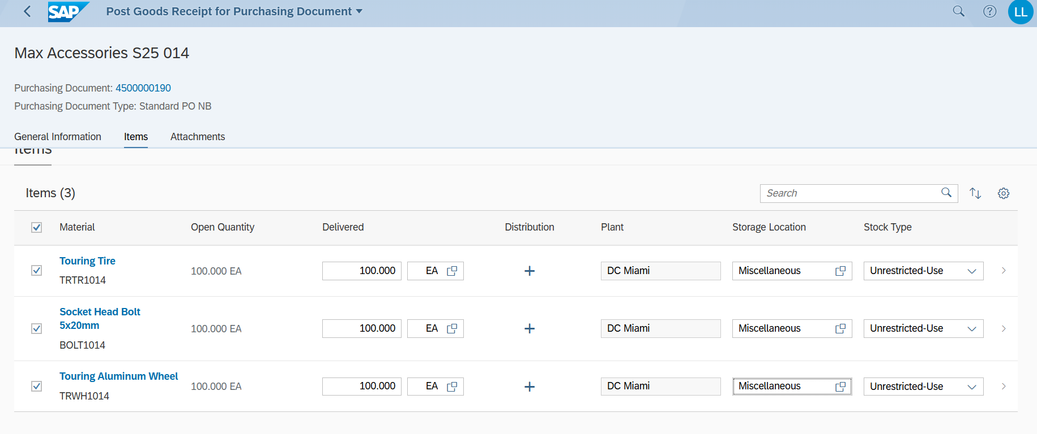

### Step 6: Check for stock

Here its shown for bolts

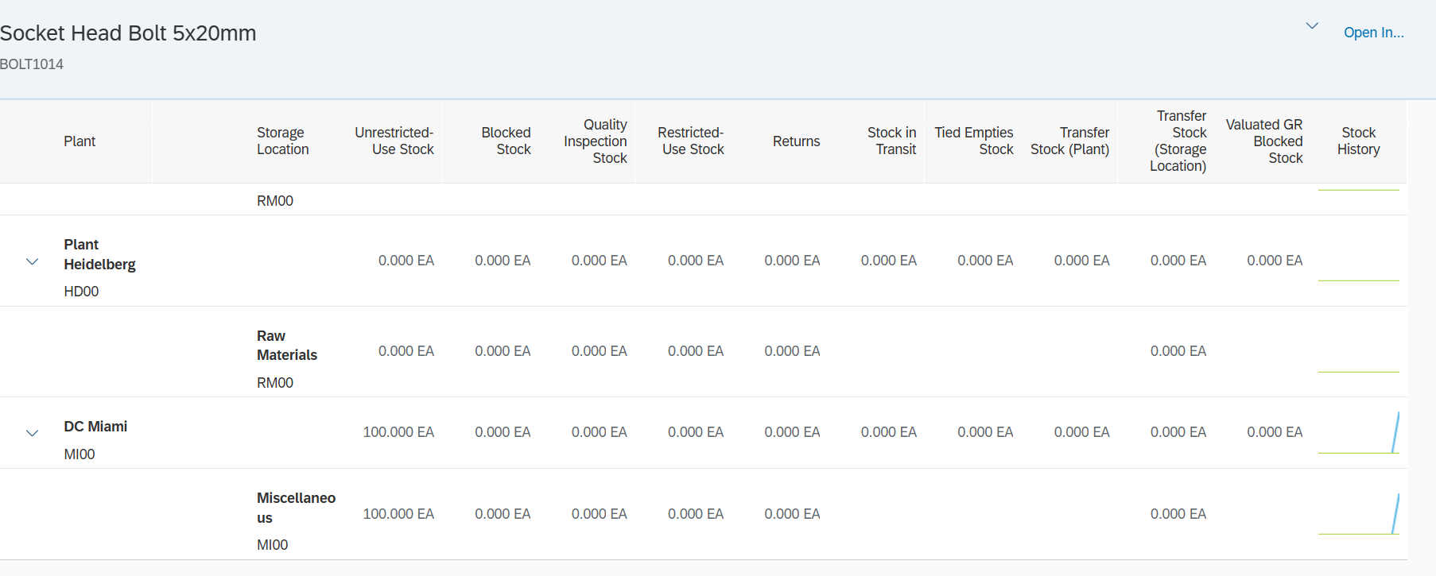

# Logistics Case Study

## Task

## Datasheet

|  |  |  |
| --- | --- | --- |
| Type (Organizational Data  /Master Data/Transaction Data) | Data | Number |
| Master Data | Business Partner (Customer)  Sport Center S25 014 | 1003425 |
| Master Data | Business Partner (Supplier) Mid-West Supply S014 | 1003159 |
| Transaction Data | Standard Order | 239 |
| Master Data | Routing Group | 50000007 |
| Transaction Data | Production Version | 2514 |
| Transaction Data | Planned Orders | [2875](https://m30z.ucc.ovgu.de/sap/bc/ui2/flp) | 2876 |
| Master Data | Purchasing Info Records (Note they are old records, I changed the price) I could not just delete and create new ones, this got me errors | TRFR3014 – 5300000116  CHAN1014 – 5300000107  TRHB1014 – 5300000120  TRSK1014 – 5300000126  TRTR1014 - 5300000130  TRTB1014 – 5300000136  TRWH1014 – 5300000144  BOLT1014 - 5300000151 |
| Transaction Data | Standard PO | 4500000217 |
| Transaction Data | Material Document | 5000000430/2025 for externally procured materials. |
| Transaction Data | Supplier Invoice | 5105600230/2025 |
| Transaction Data | Production Order | 1000294 | 1000293 |
| Transaction Data | Order Confirmation (Within Manage Production Orders > Confirmation) | 933 | 932 (For TRWA1014)  934 | 935 | 936 (for DXTR3014) |
| Transaction Data | Material Document | 5000000433/2025 – 1000293; for TRWA1014  5000000434/2025 – PO 1000294 ; for DXTR3014 |
| Transaction Data | Outbound Delivery | 80000124 |
| Transaction Data | Goods Issue Posted | 4900032478 |
| Transaction Data | Invoice Billing Number | 90000103 |

## Process steps

### Step 1: Create Business Partner / Customer

Description & Screenshots

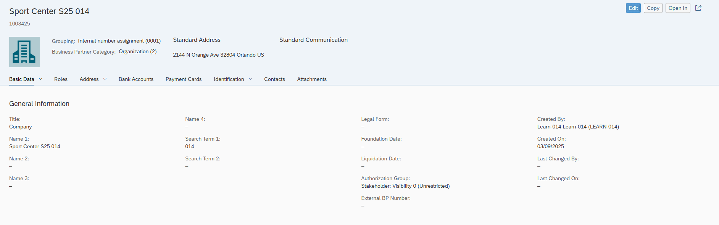

*Research what Incoterms are and what FOB*

Incoterms are like a rulebook for buyers and sellers in global trade, sorting out who handles shipping, costs, and risks. FOB, or Free on Board, means the seller gets the stuff onto a ship and pays until it’s loaded—then it’s the buyer’s headache for the rest of the trip.

### Step 2: Create Customer Sales Order

Issue with my material : DXTR3014. This issue was resolved within class for my particular case.

Task – Discuss the availability date

In my case 03/22/2025 comes about as the 10 day delivery time for the item.

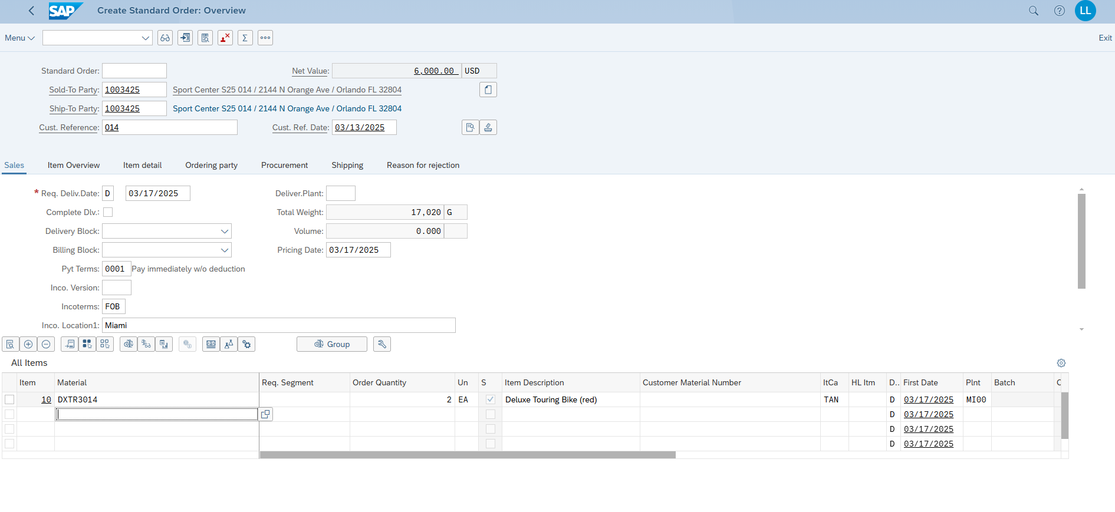

Step 3: Show Manage Material Coverage

Plant: MI00

Stock: 0

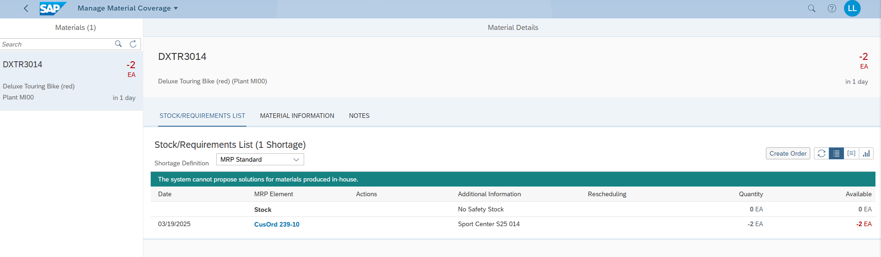

Discuss where the availability date comes from

In customer orders, the availability date in SAP comes from checking the stock on hand and the delivery schedule. It’s basically when the system figures out the goods can be ready to ship, based on what’s in the warehouse or when more is coming in.

### Step 3: Display multilevel BOM ....

Description & Screenshots

TRWA1014

Includes:

* TRTR1014 – Touring Tire Quantity: 1
* TRTB1014 – Touring Tube Quantity: 1
* TRWH1014 – Touring Aluminum Wheel Quantity: 1
* BOLT1014 – Socket Head Bolt 5x20mm Quantity: 2

Create Alternative

Example shown for TRWA1014

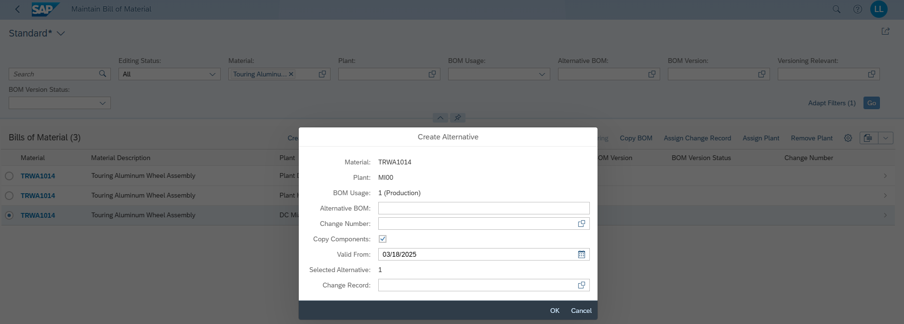

TRWA1014 - Alternative: 02

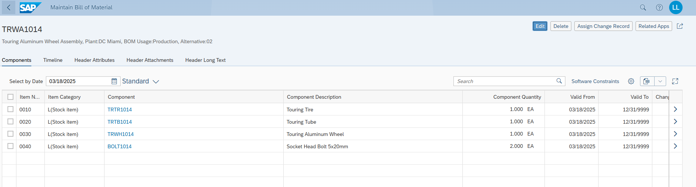

DXTR3014 – Alternative: 02

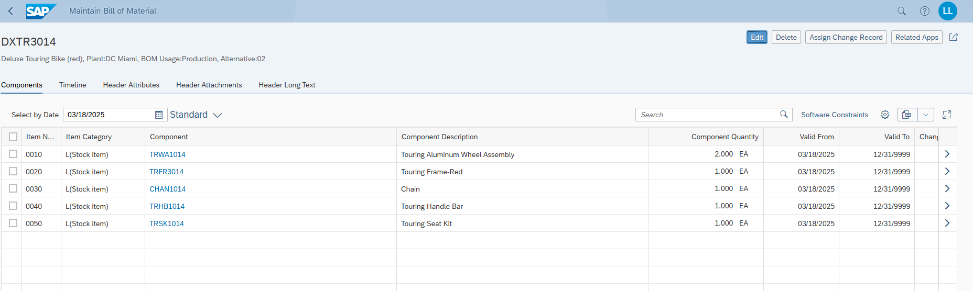

DXTR3014

Includes:

* TRWA1014 – Touring Alininum Wheel Assembly Quantity: 2
* TRFR3014 - Touring Frame-Red Quantity: 1
* CHAN1014 – Chain Quantity: 1
* TRHB1014 - Touring Handle Bar Quantity: 1
* TRSK1014 - Touring Seat Kit Quantity: 1

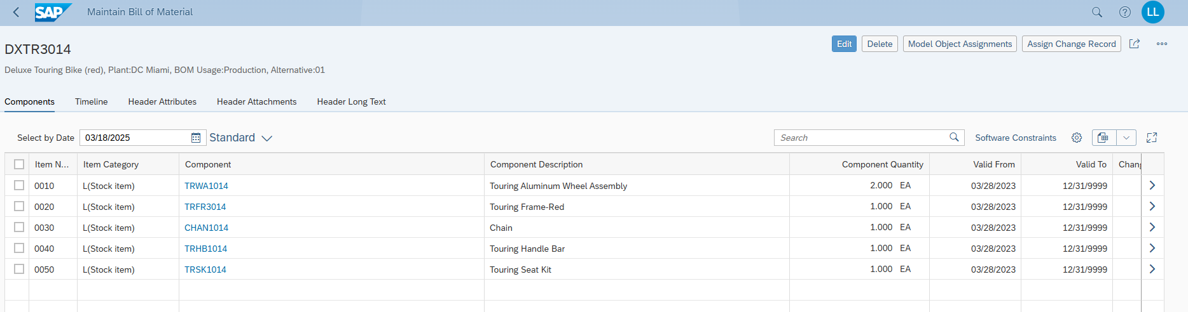

Final Step -Display Multilevel BOM

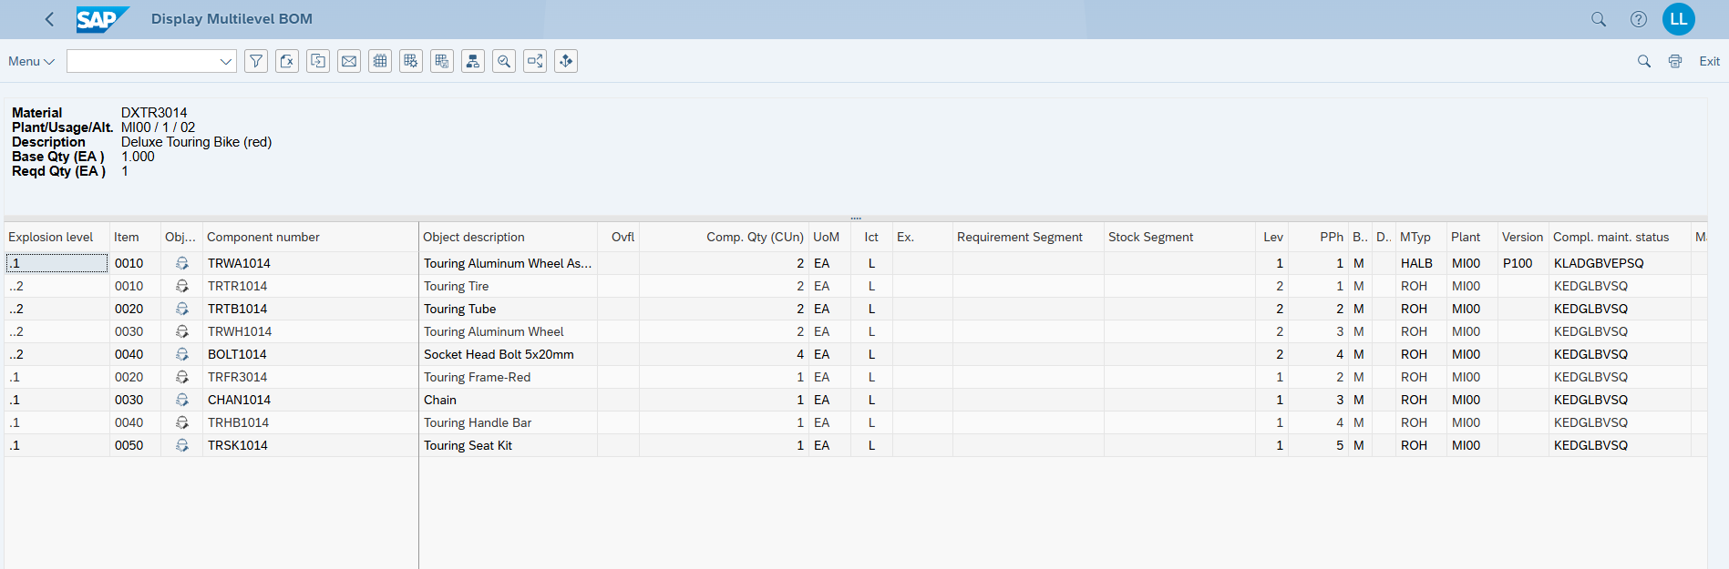

### Step 4: Create Routing

Description & Screenshots

TRWA1014

Here we see I chose Alt. BOM 2 for my prior created alternative.

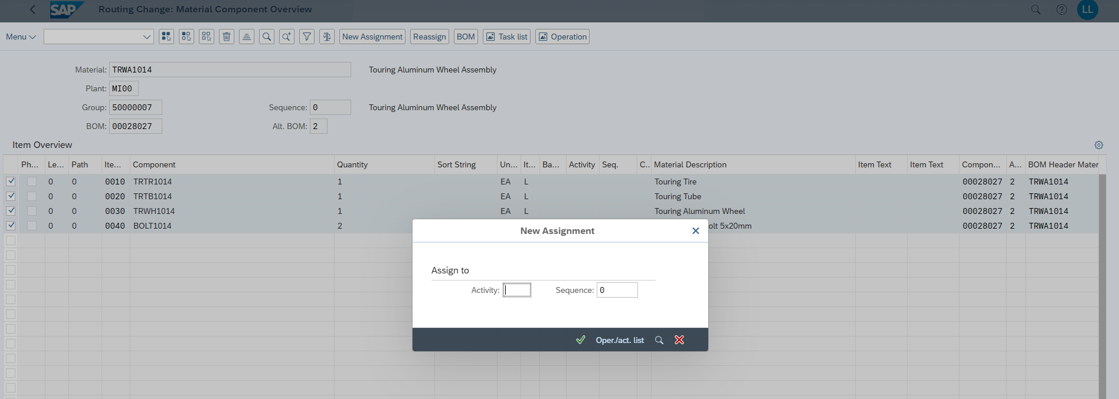

I chose the entries -> New assignment -> Oper/act list -> chose assembly and saved the already existing routing or rather updated it with the Alt. Bom of 2DX

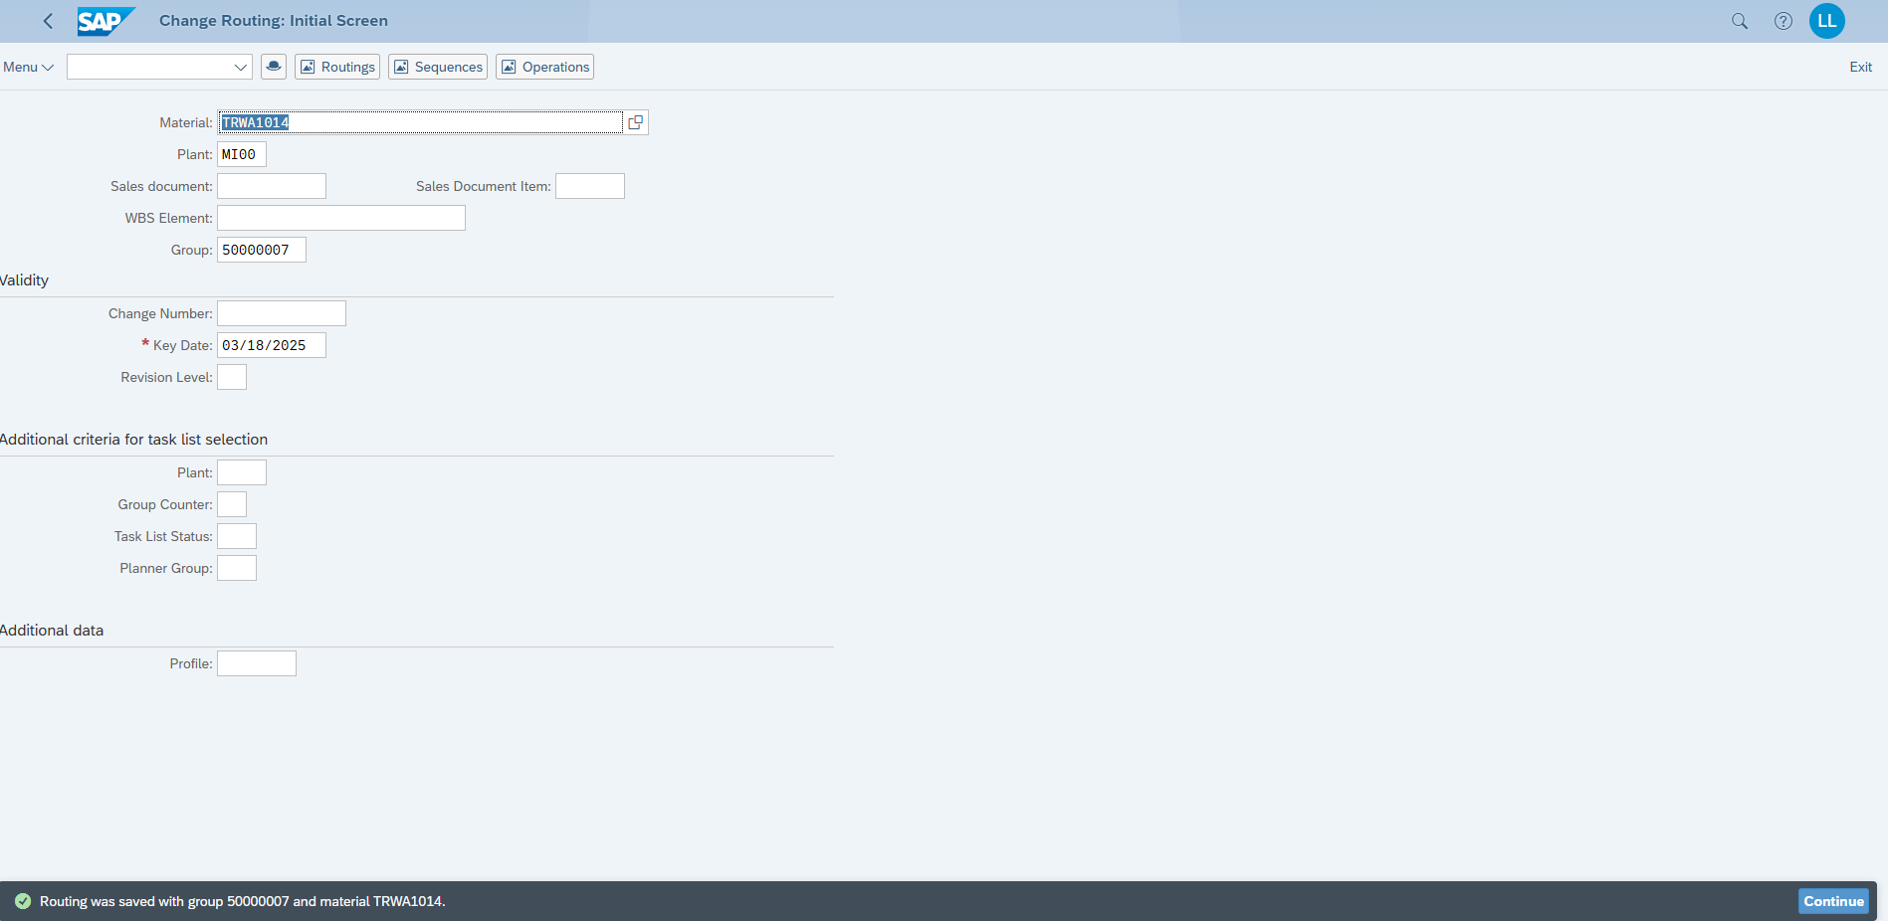

DXTR3014

Again Alt. Bom of 2

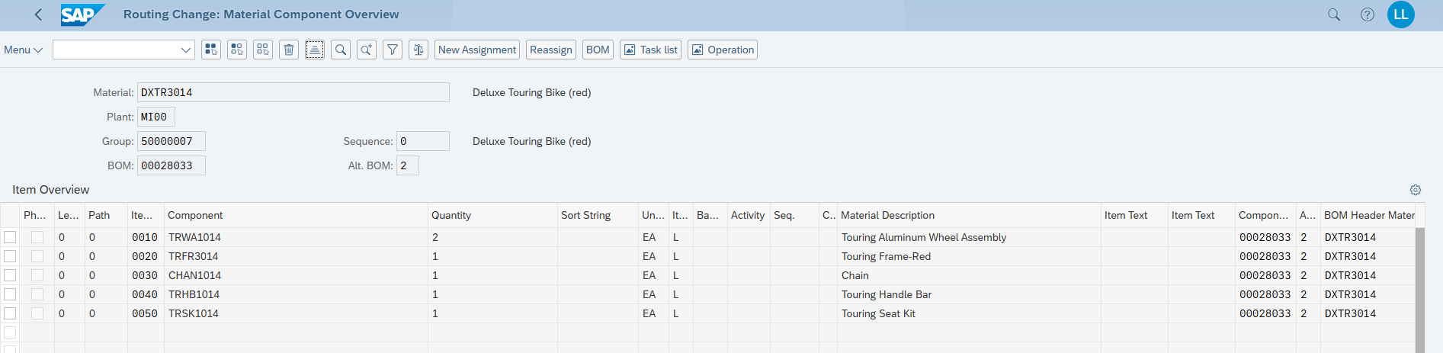

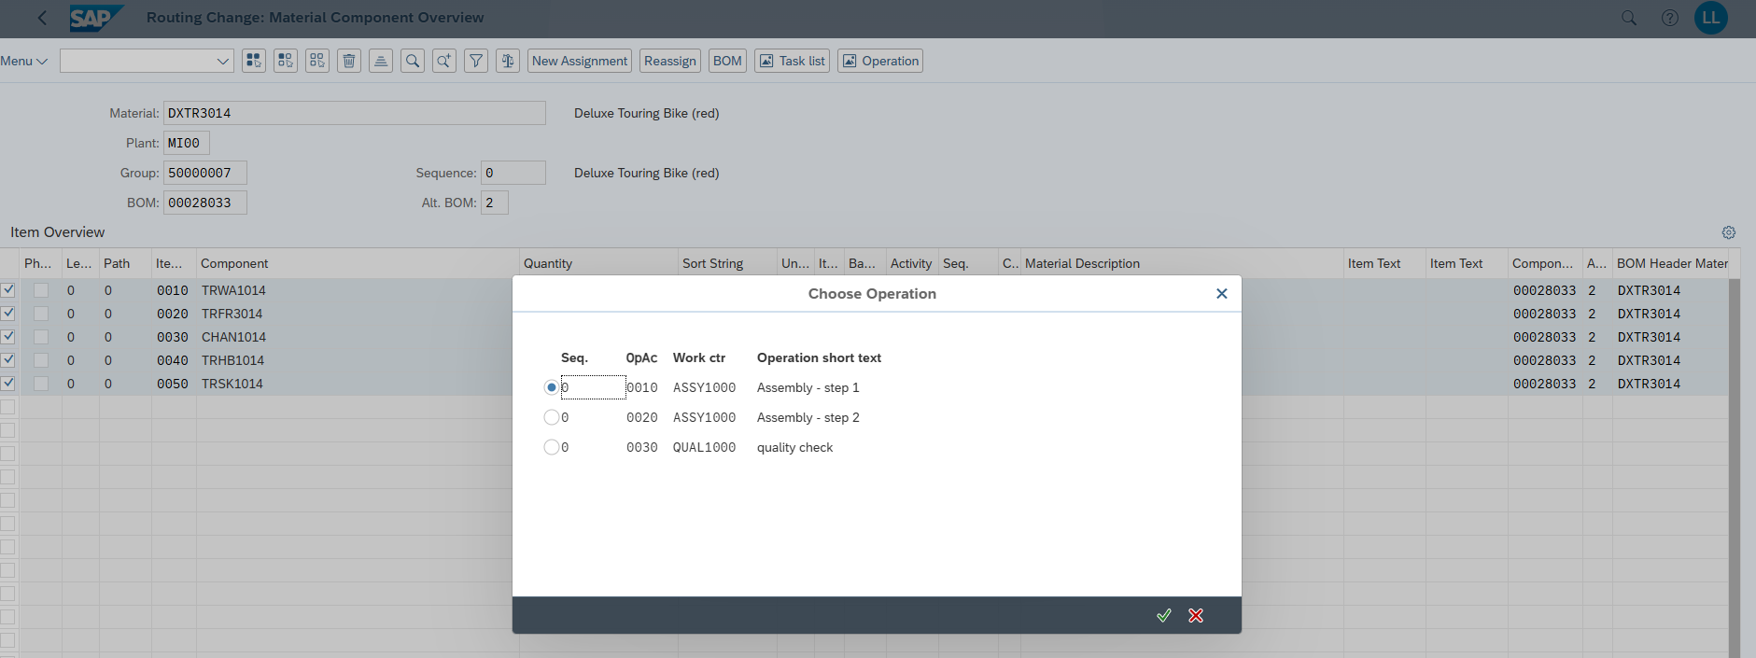

Saved

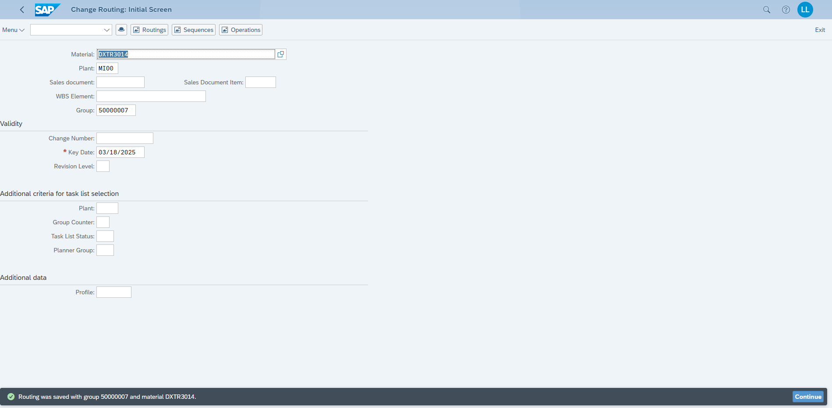

### Step 5: Production Versions

Discuss what the purpose of this may be

Production versions in SAP are like blueprints that tell the system how to make a product. They pull together the ingredients list (BOM) and the how-to steps (routing) so everyone knows exactly what’s needed and how to do it. They’re there to keep things running smoothly

Description & Screenshots

TRWA1014

Production Version: 2514 (as requested in teams chat)

Alternative BOM: 2

Group (Routing): 50000007

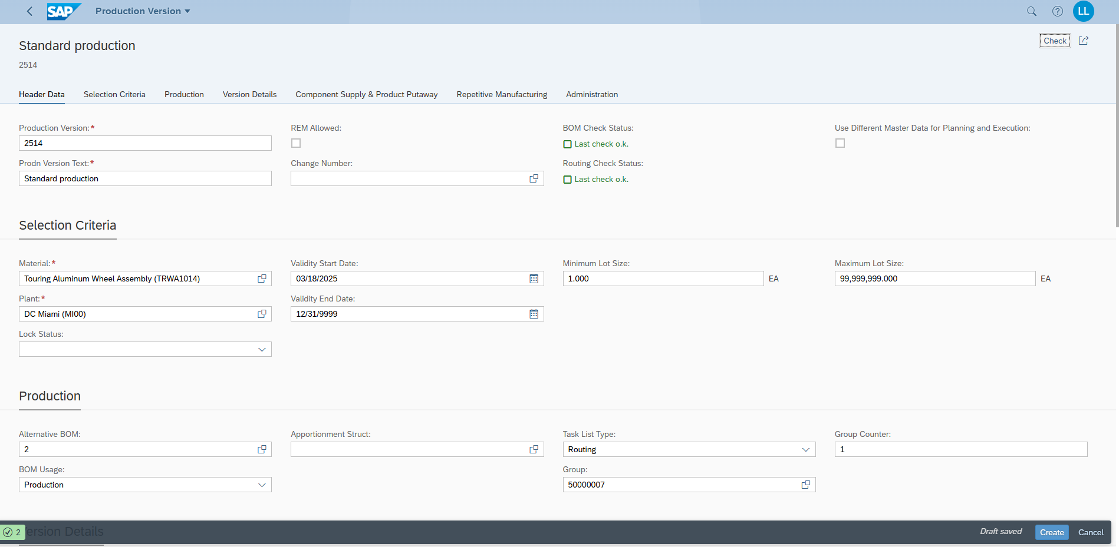

DXTR3014

Production Version: 2514 (as requested in teams chat)

Alternative BOM: 2

Group (Routing): 50000007

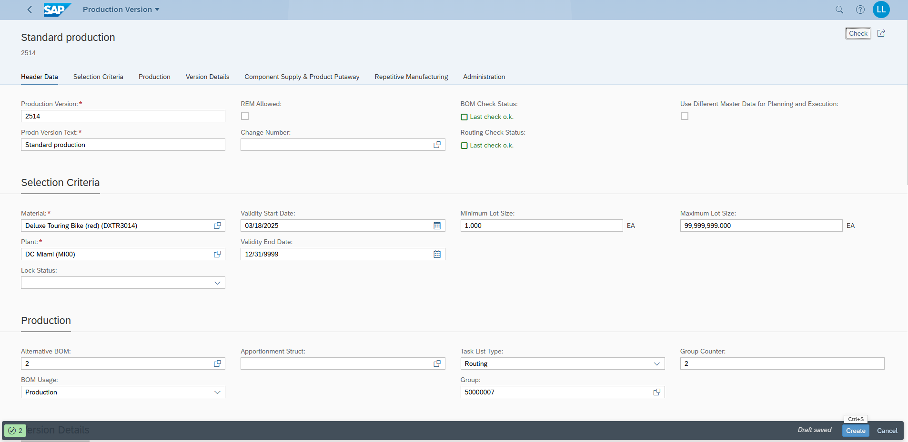

Verification creation of Production Versions for TRWA1014 & DXTR3014

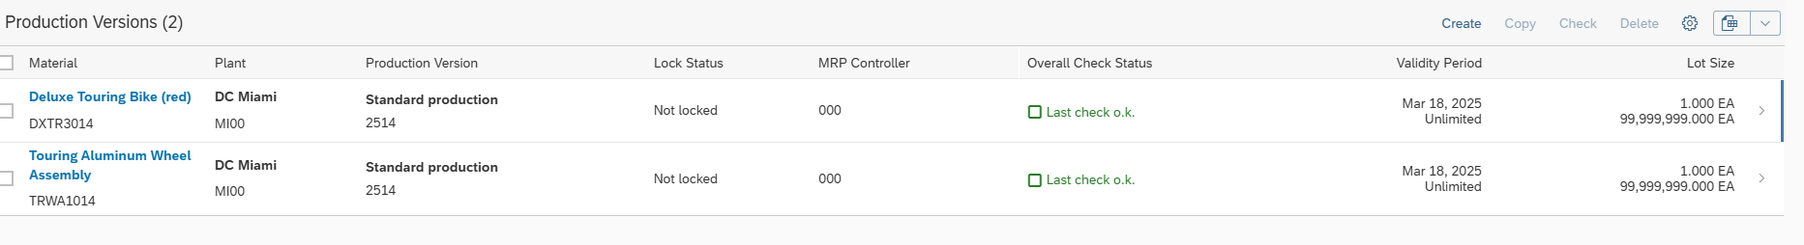

### Step 6: Material Requirements Planning (MRP)

Research what the MRP run does.

The MRP run in SAP analyzes inventory, customer orders, and production needs to determine what materials or products are required. It generates purchase requisitions or production orders to ensure timely availability, preventing shortages or excess stock.

Discuss what the red and green bars mean

In material coverage stock, the red bars show when your stock is too low to meet demand—like a warning that you might run out. Green bars mean you’ve got enough on hand to cover what’s needed, so you’re good to go. It’s a quick way to spot shortages or surpluses.

Description & Screenshots

Select my BOM with alternative 2 and the other materials

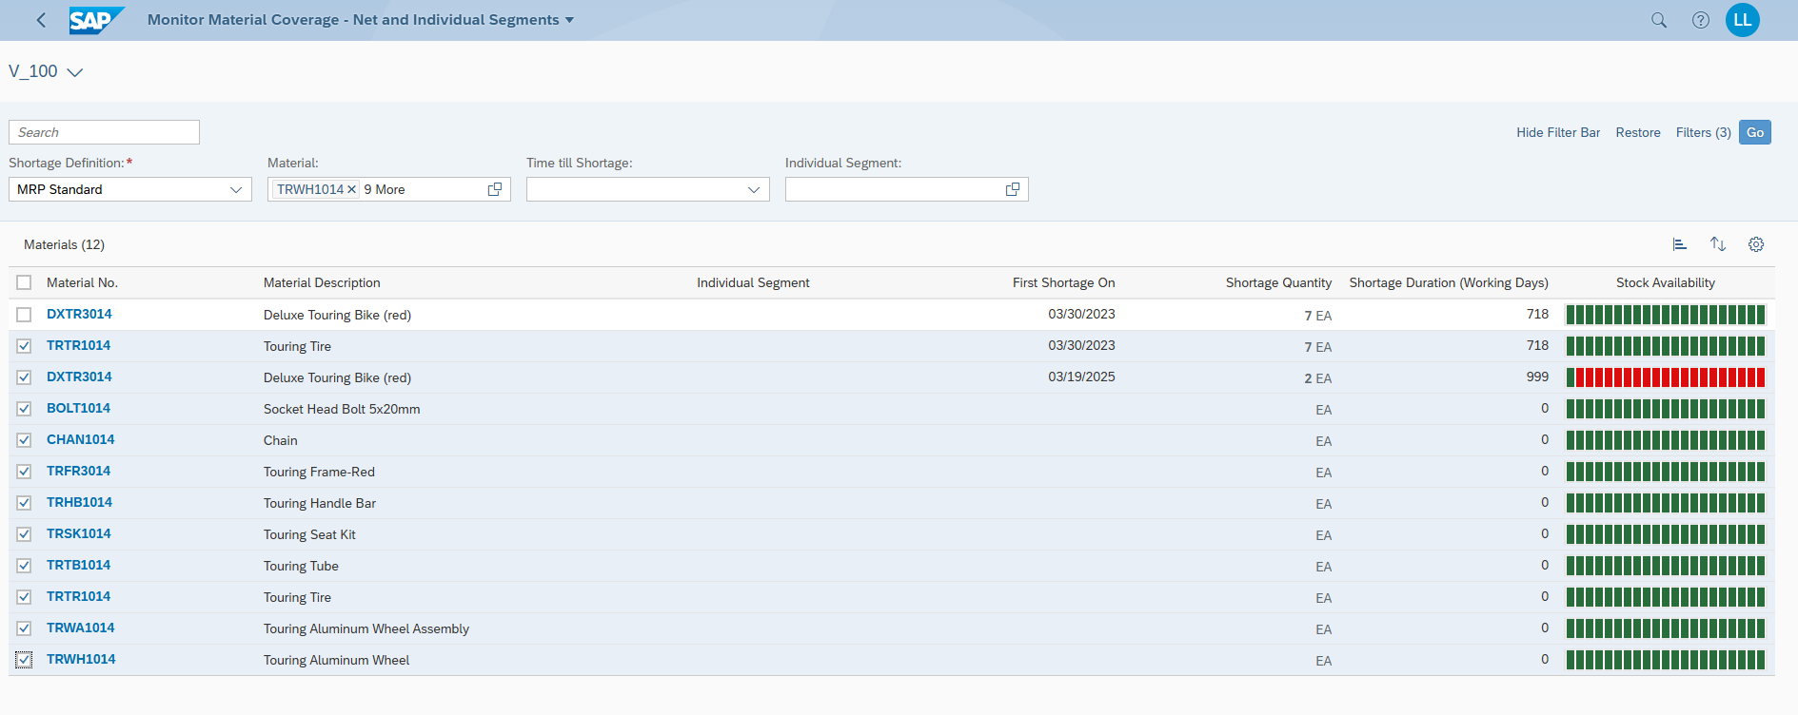

### Step 6.5: Planned Order

Discuss what purchase requisitions are needed for

They are used as internal requests and when you don’t have enough materials on stock for production. They are there to order.

Screenshot of MRP run and overview in app. DXTR3014 is processed now.

Planned Order: 2875

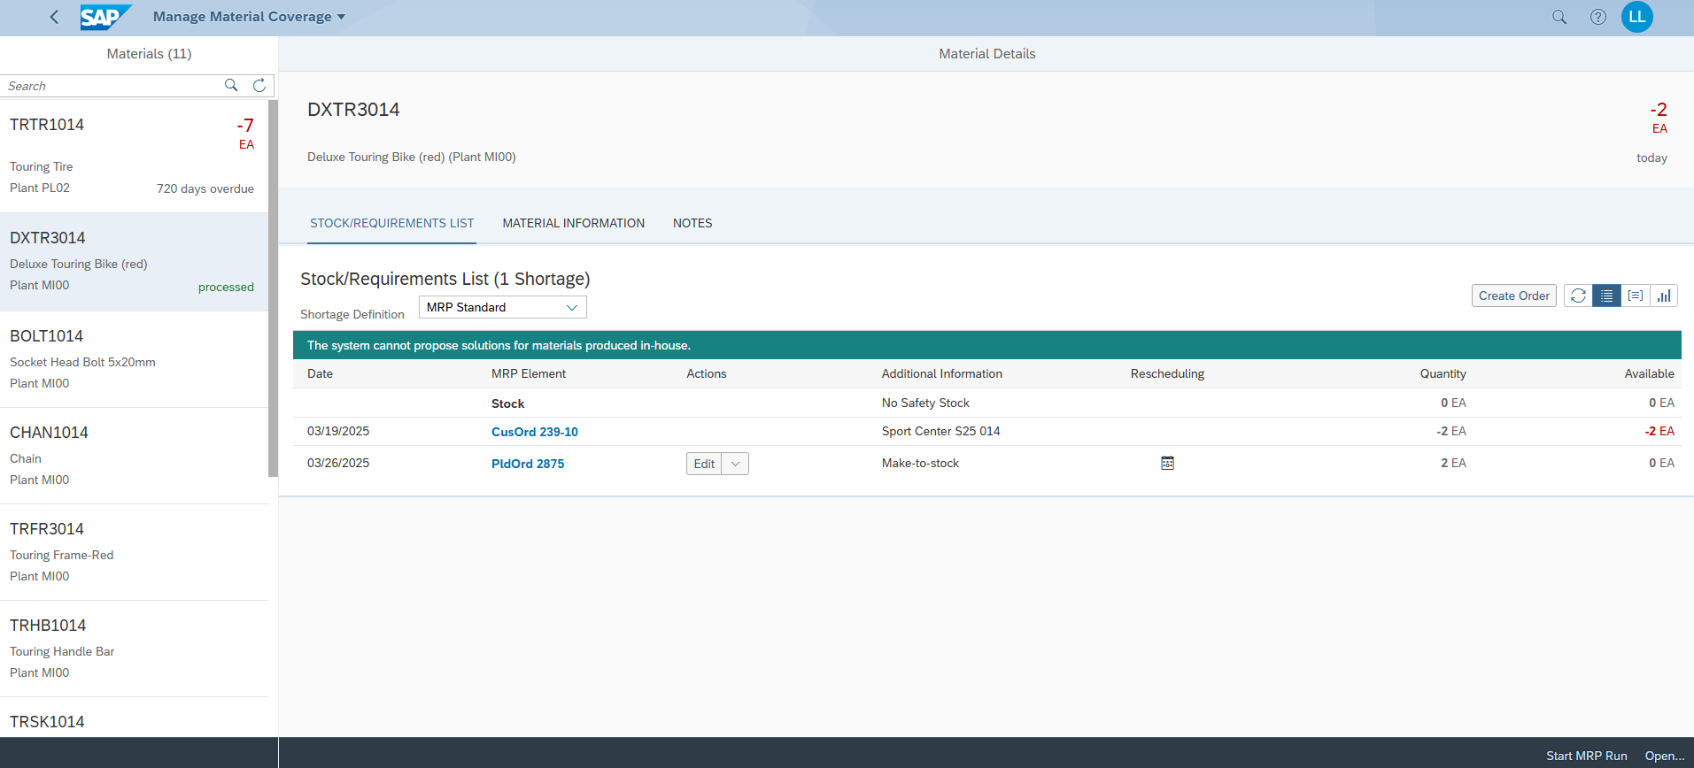

TRWA1014

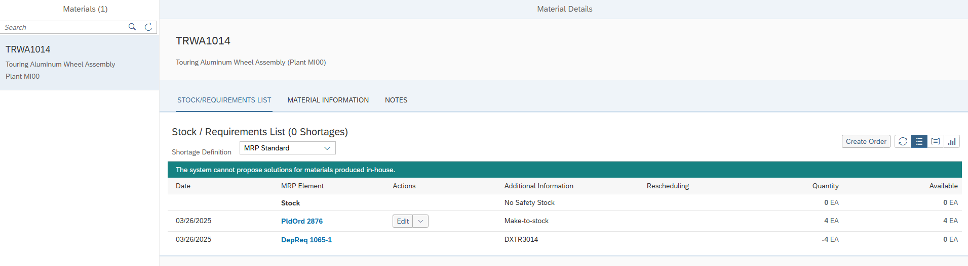

### Step 7: Purchasing Info Records

Discuss what Incoterms are needed for

They describe precisely when the responsibility and risk from buyer and seller go from one part to the other. Handle shipping, costs, and risks.

All 8 items. The records were there already from last year but with huge prices and those I changed to be more reasonable as you described in the task.

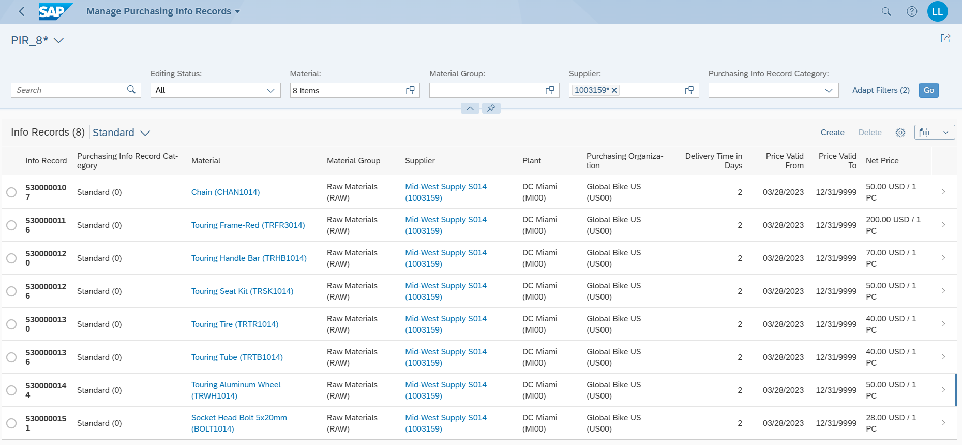

### Step 8: Purchase Order

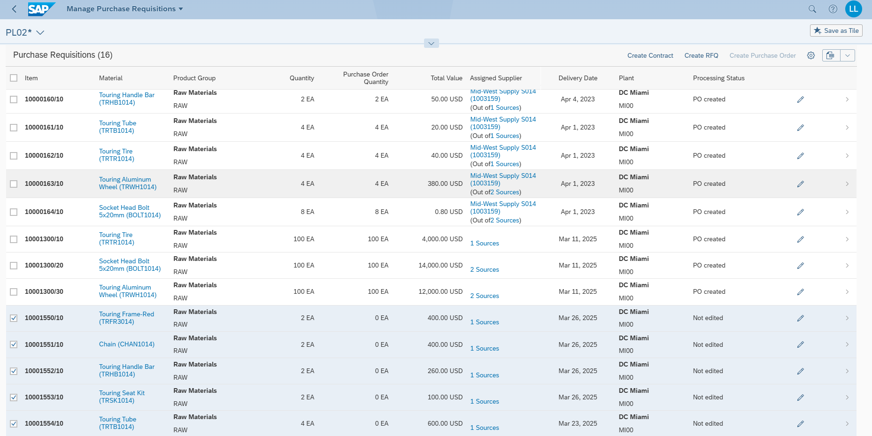

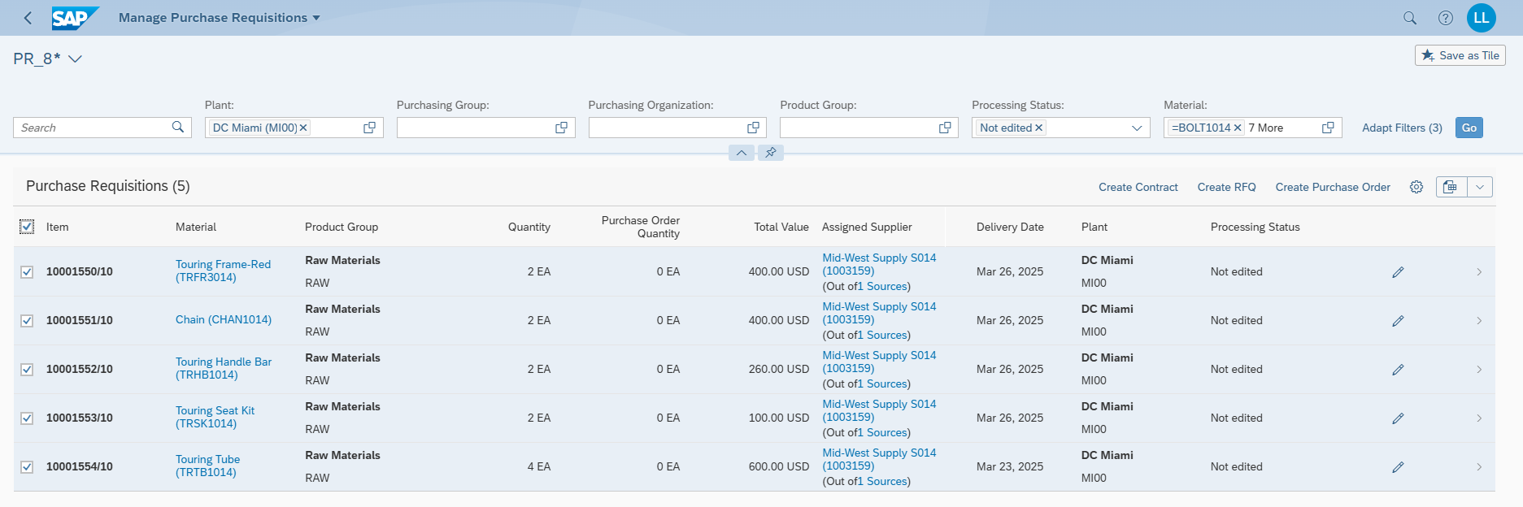

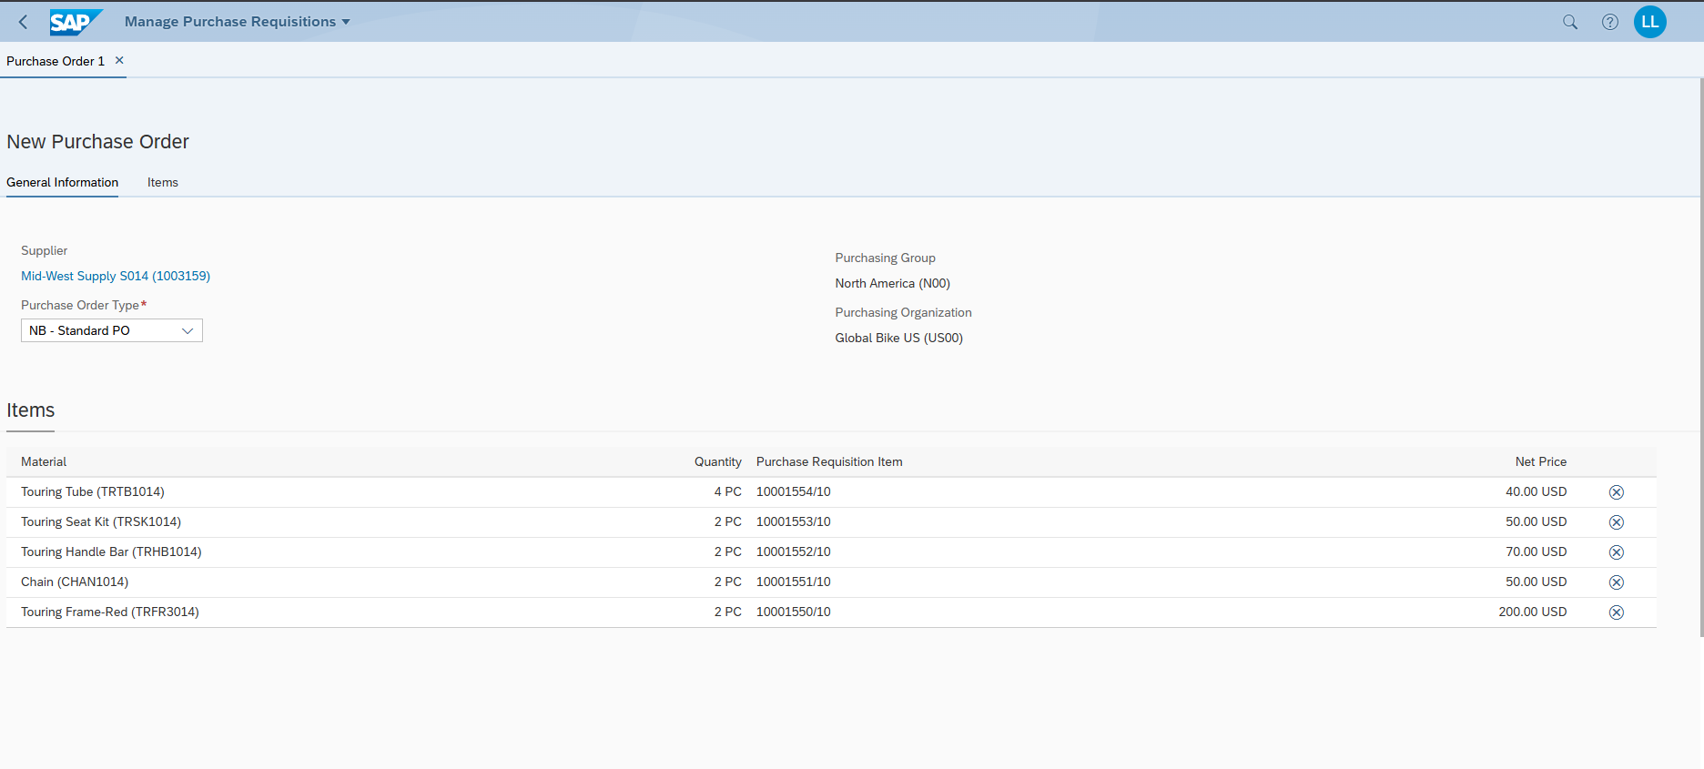

Standard PO

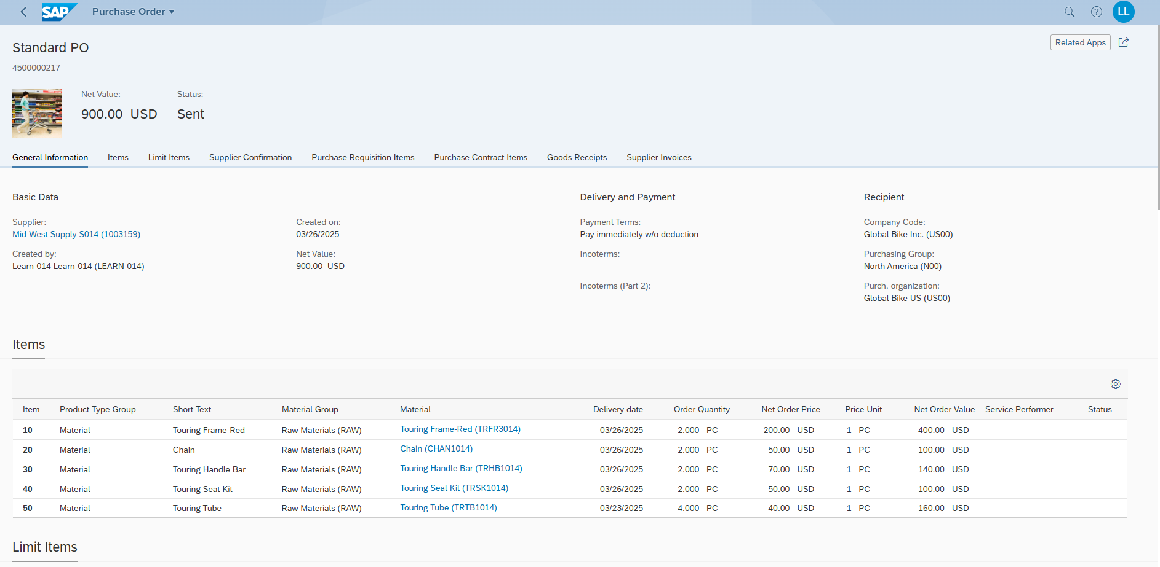

Printout

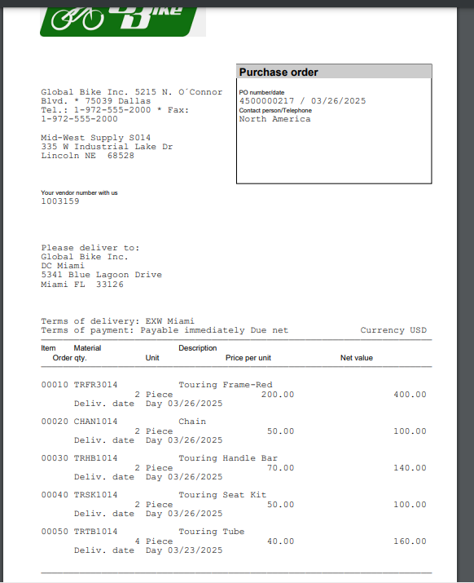

### Step 9: Goods Receipt

Mark all with Storage location miscellaneous

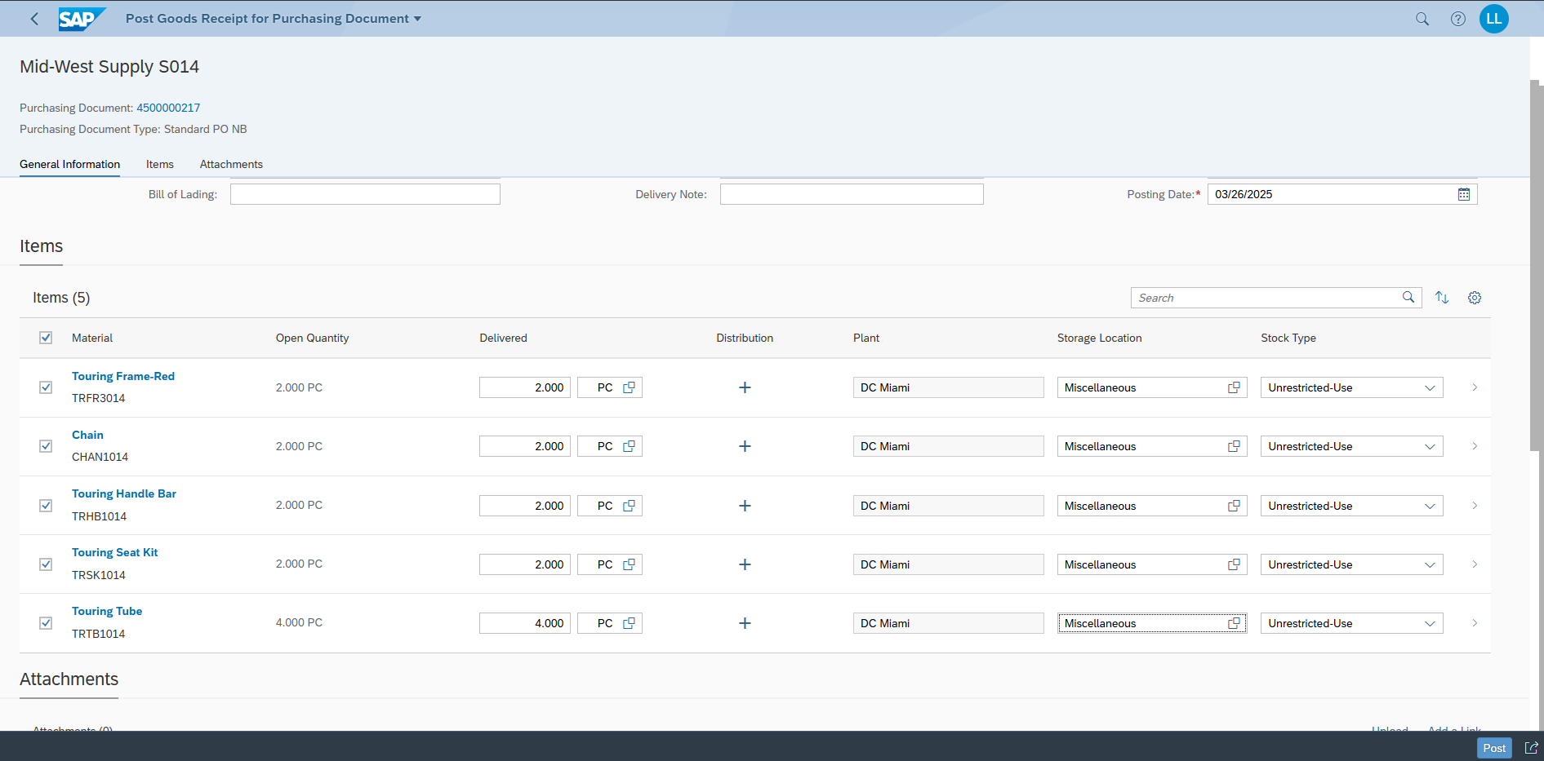

### Step 10: Supplier Invoice

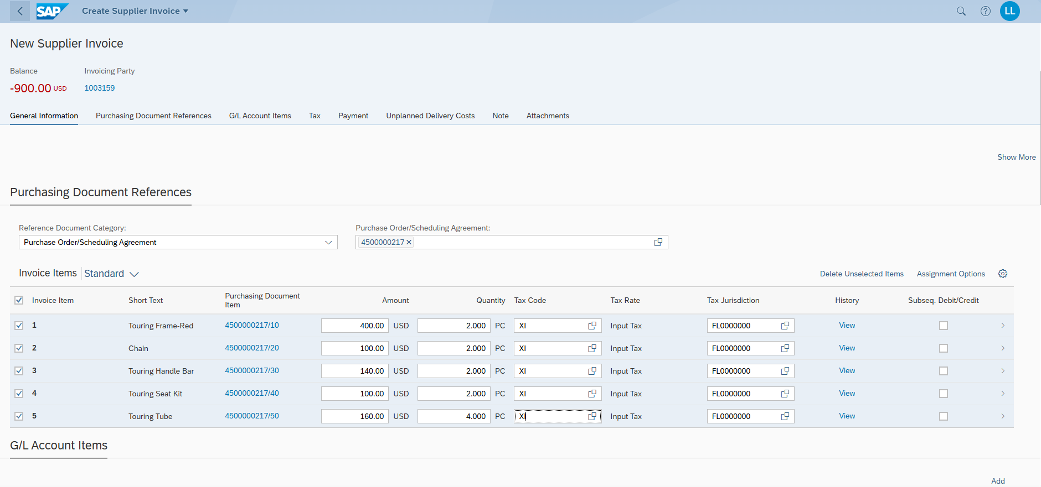

Discuss what you see in the simulation

Well it shows how much the buyer would need to pay and the payment. In the end both sides should be put with the same amount so its correct.

### Step 11: Production Order

TRWA1014

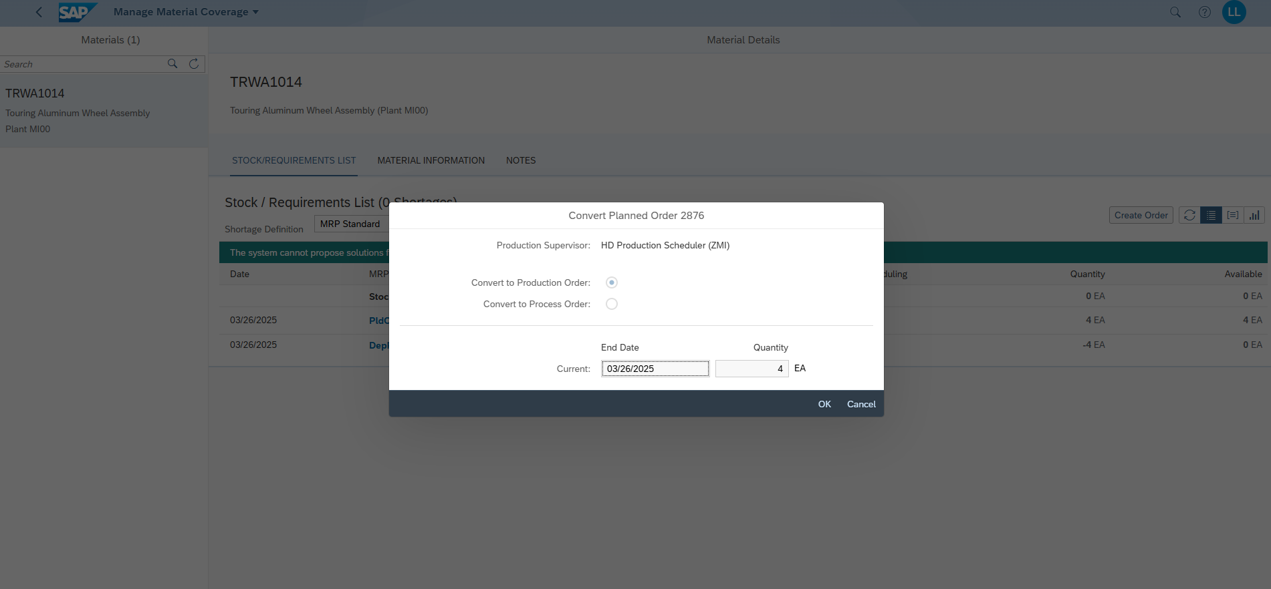

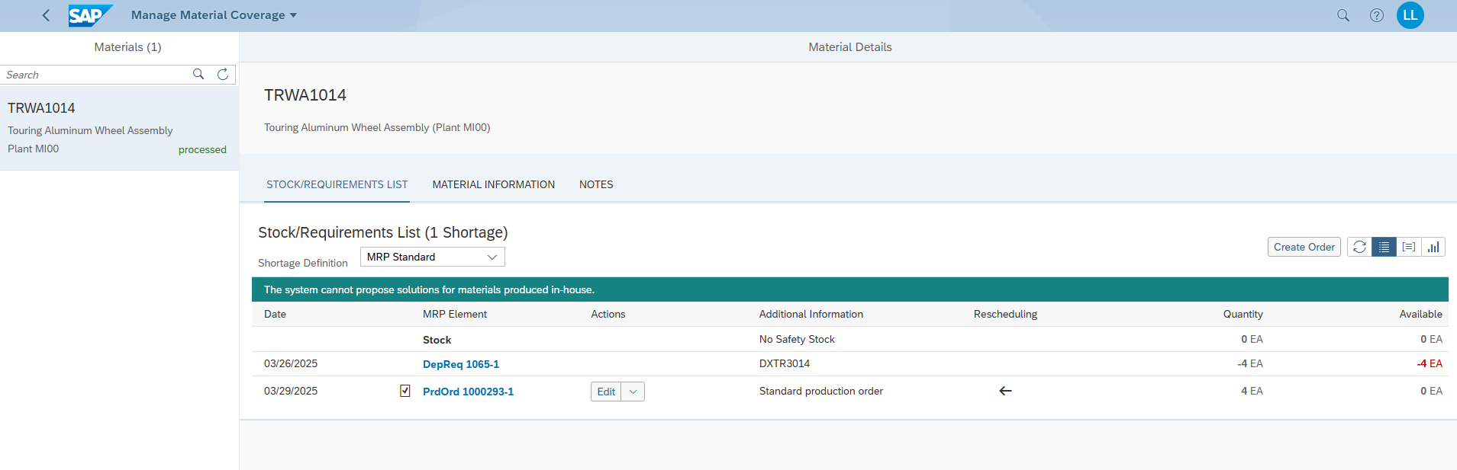

DXTR3014

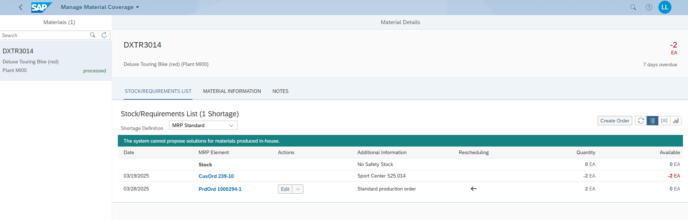

For semi finished good

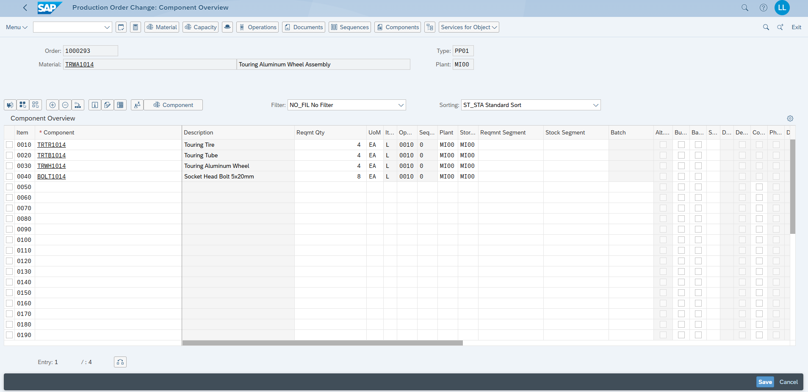

Operations > Routings

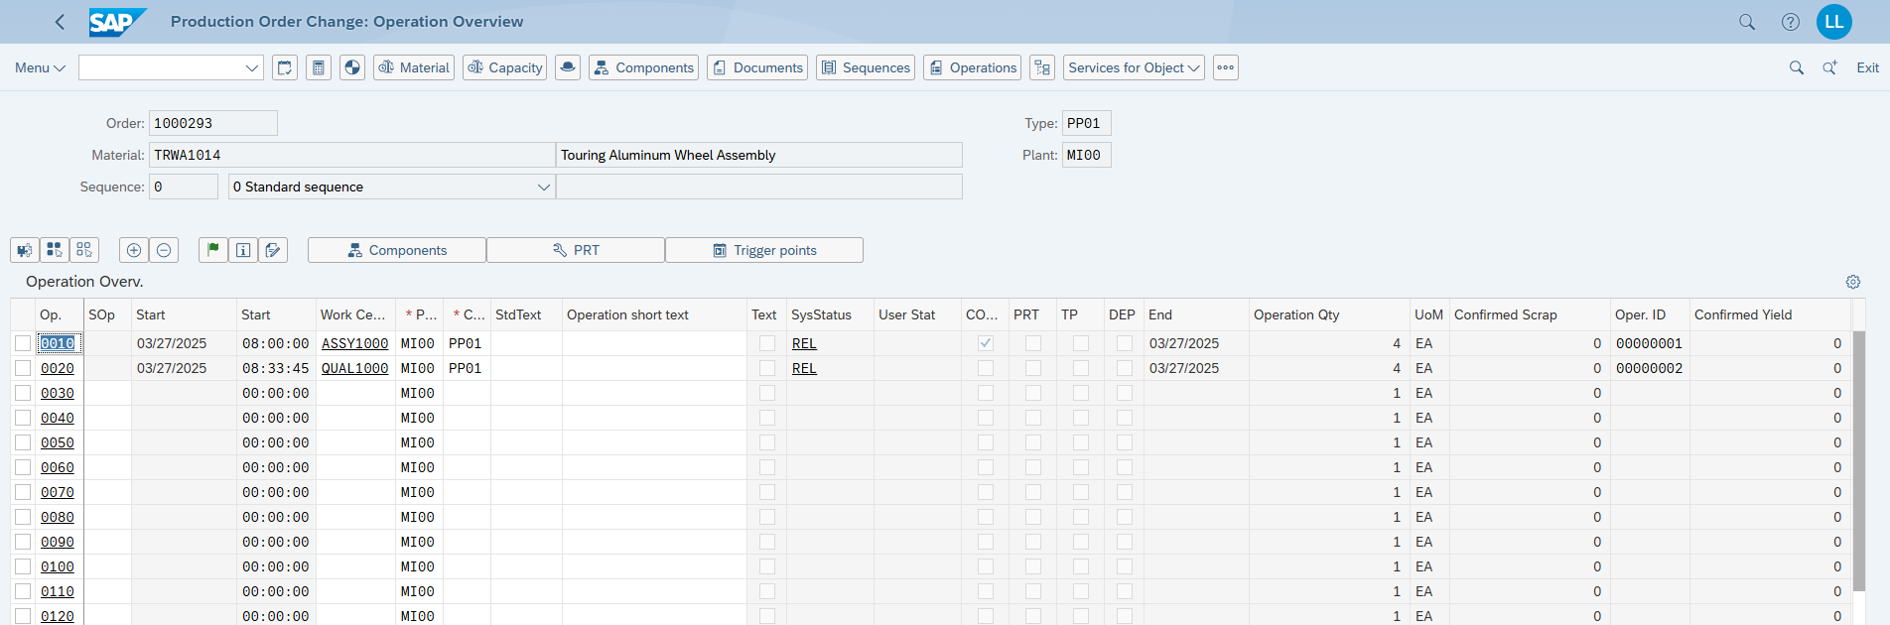

NO Issue here: For the semi finished good the TRWA1014 it says everthing available

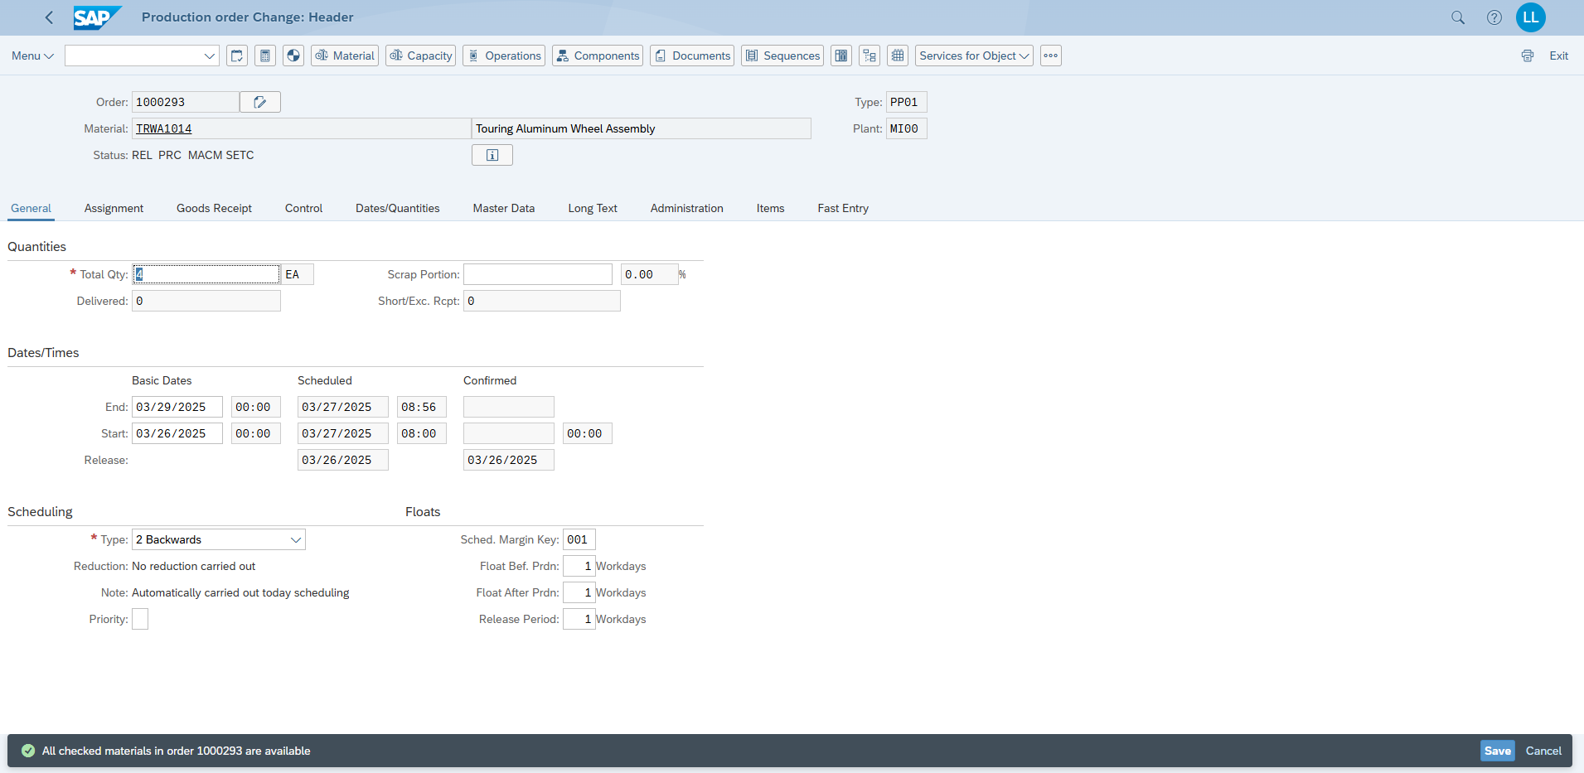

Cost Trend

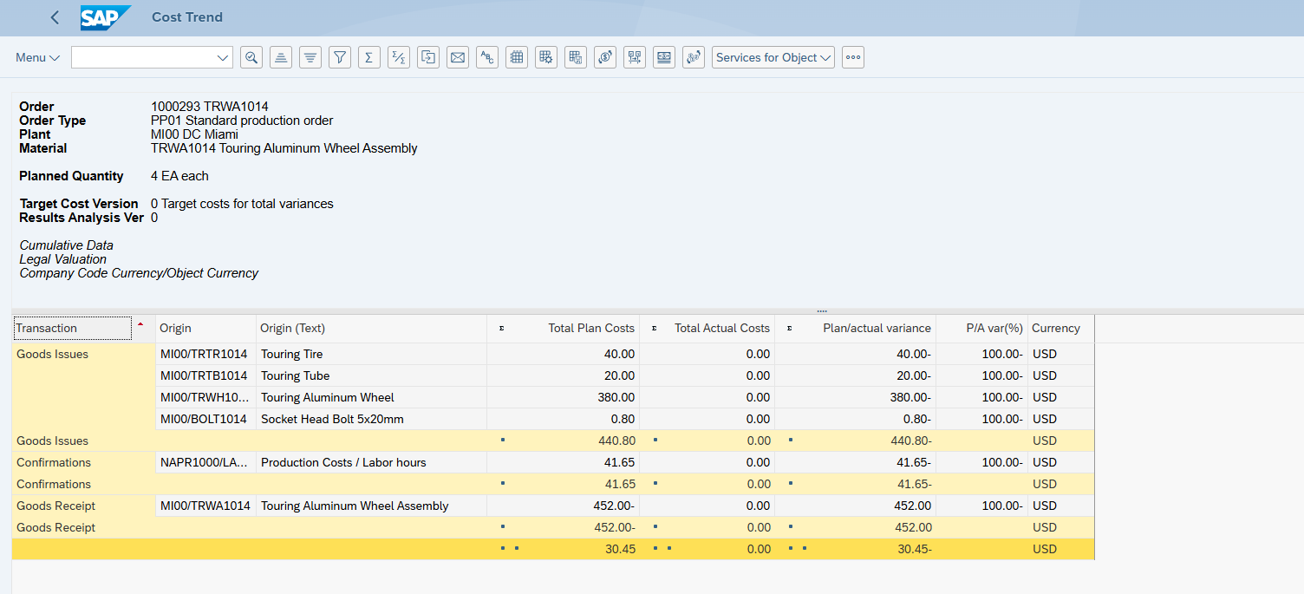

Here we see the cost analysis. Discuss the outcome.

It’s showing what it’ll cost to make the assembly, but since it’s just a plan, there are no actual costs or variances to compare yet.

Order Number (Production Order): 1000293

Picking Components

Semi finished good TRWA1014

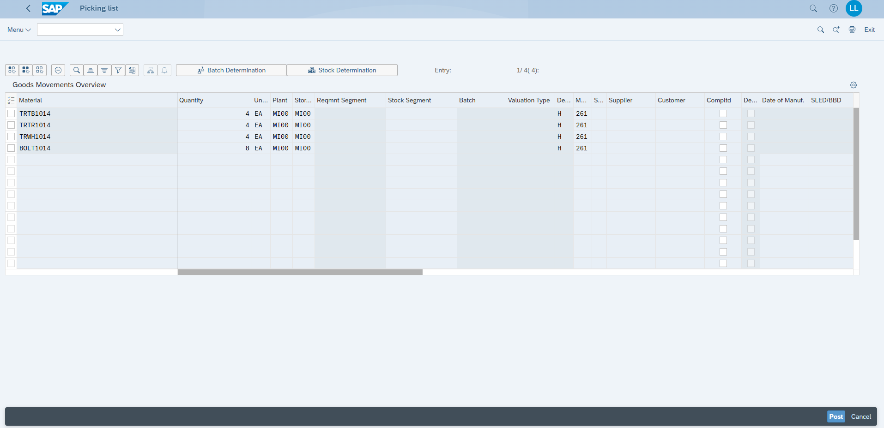

Empty after refresh

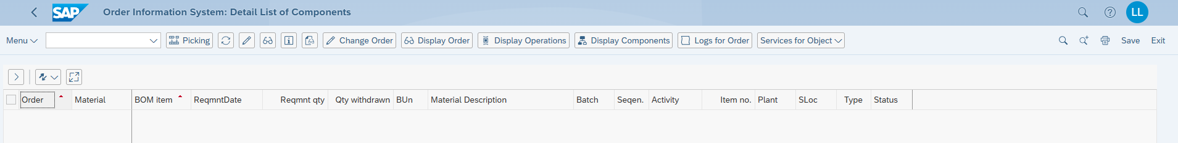

Confirm Production Order

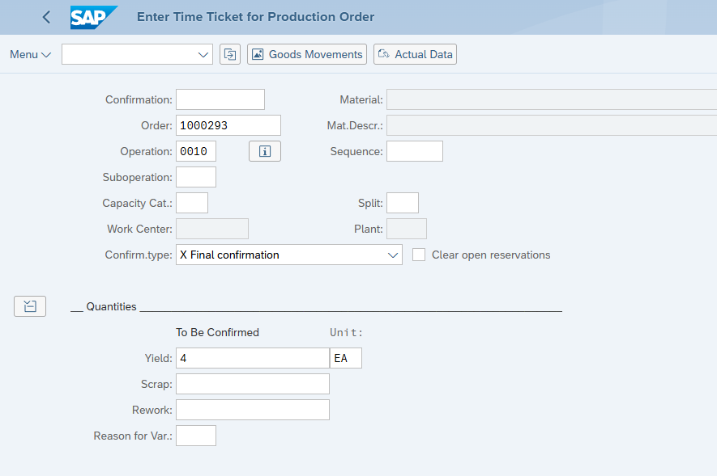

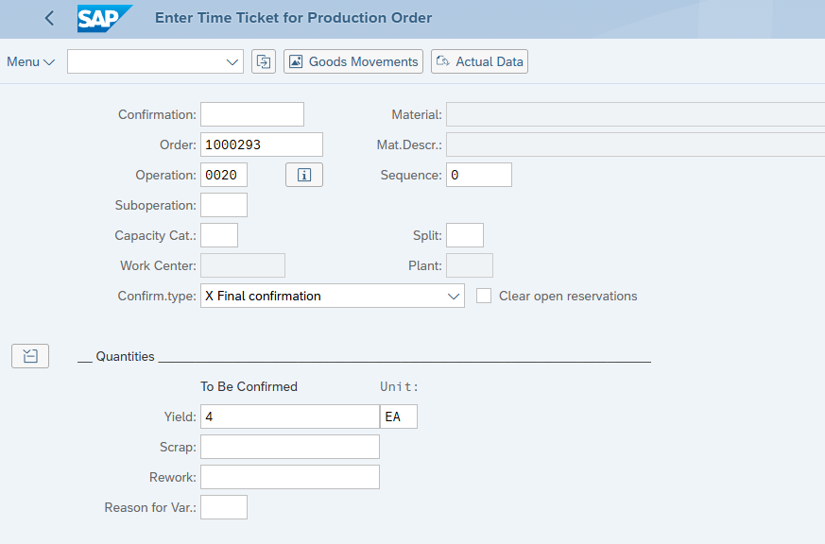

Manage Production Orders TRWA1014

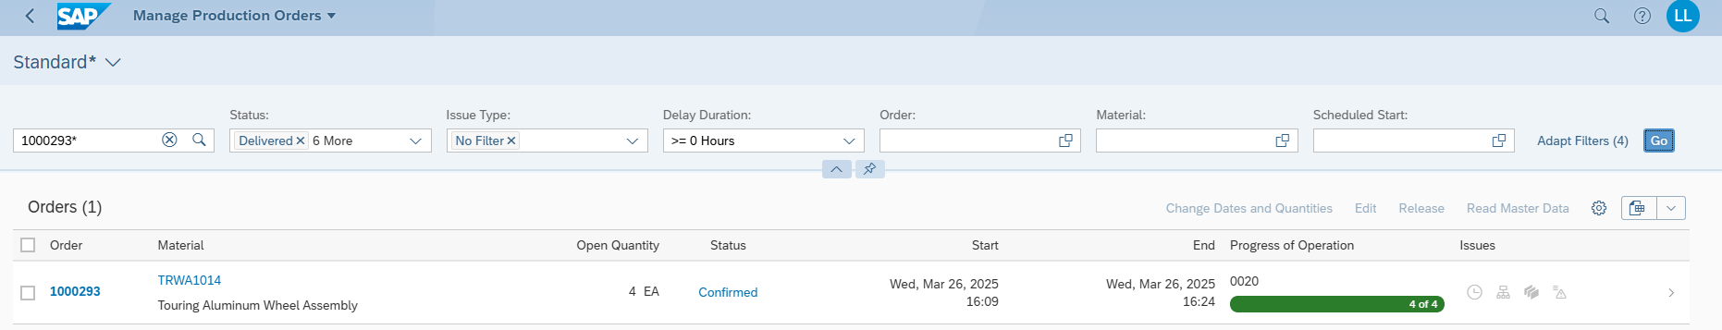

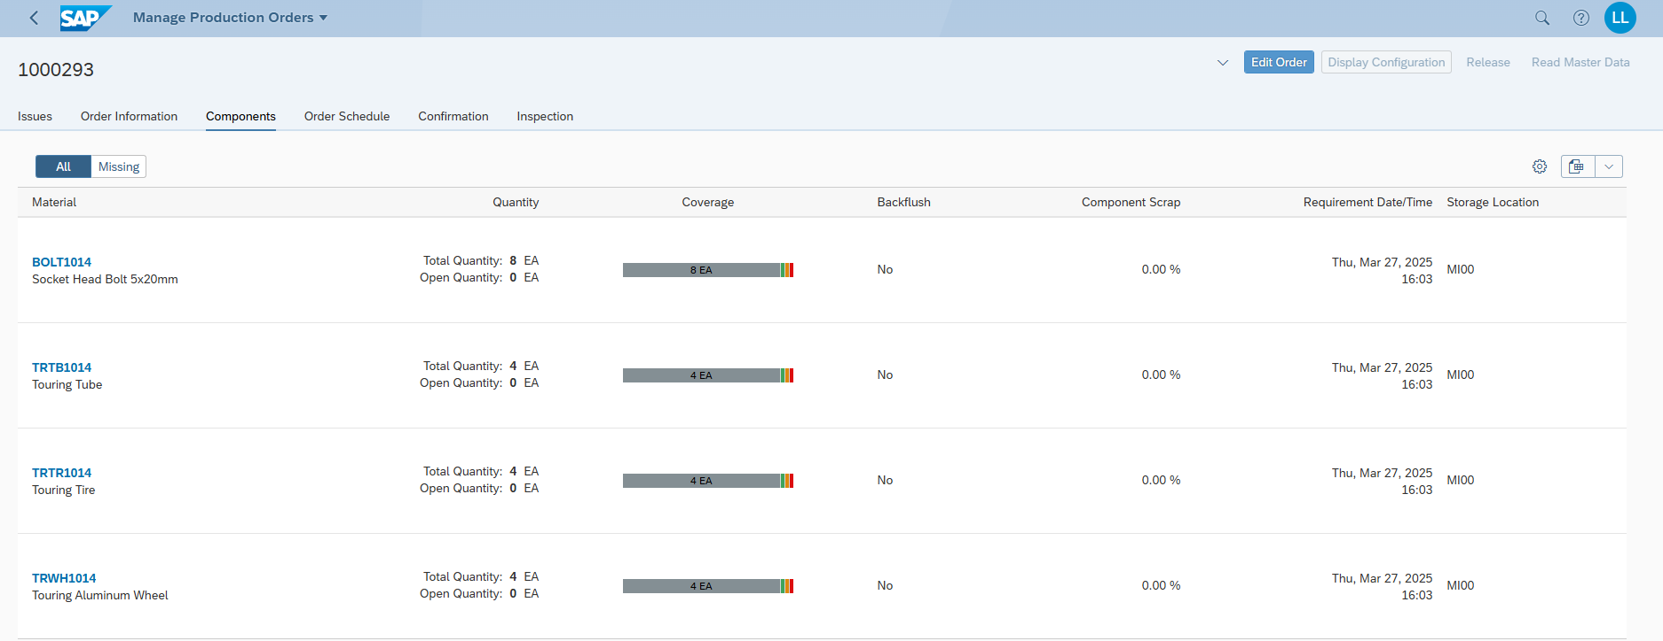

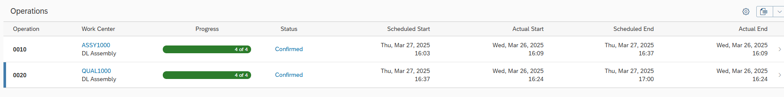

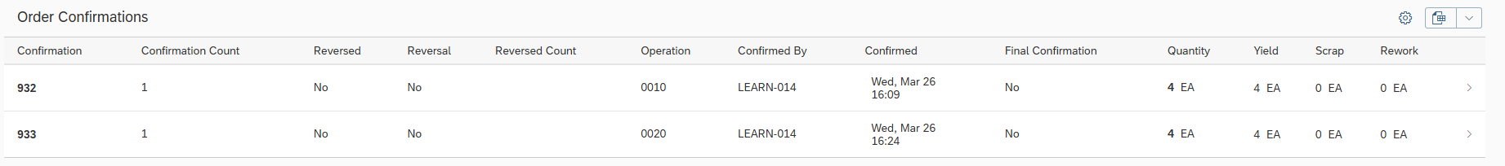

Add Storage Location Miscellaneous and Post Goods Receipt.

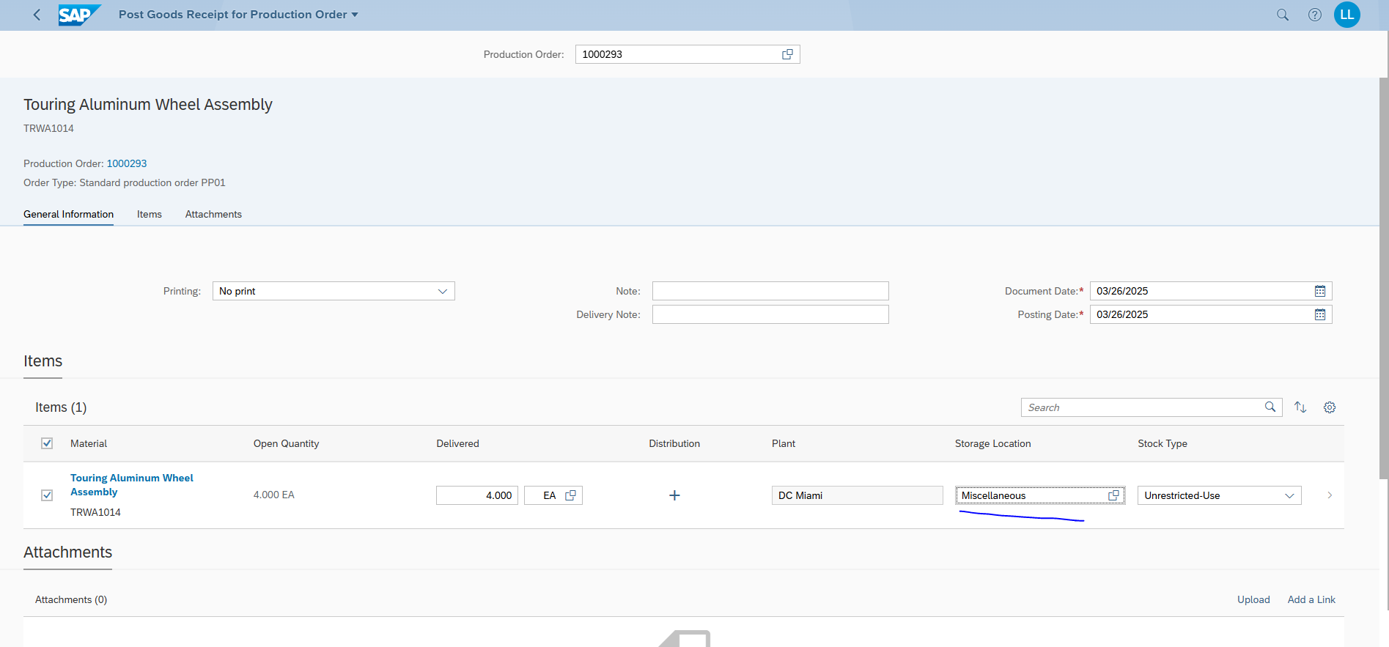

Stock of TRWA1014

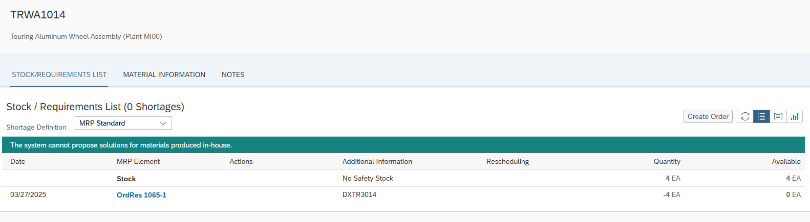

Now for finished good DXTR3014

Issue from before was resolved and all materials are available

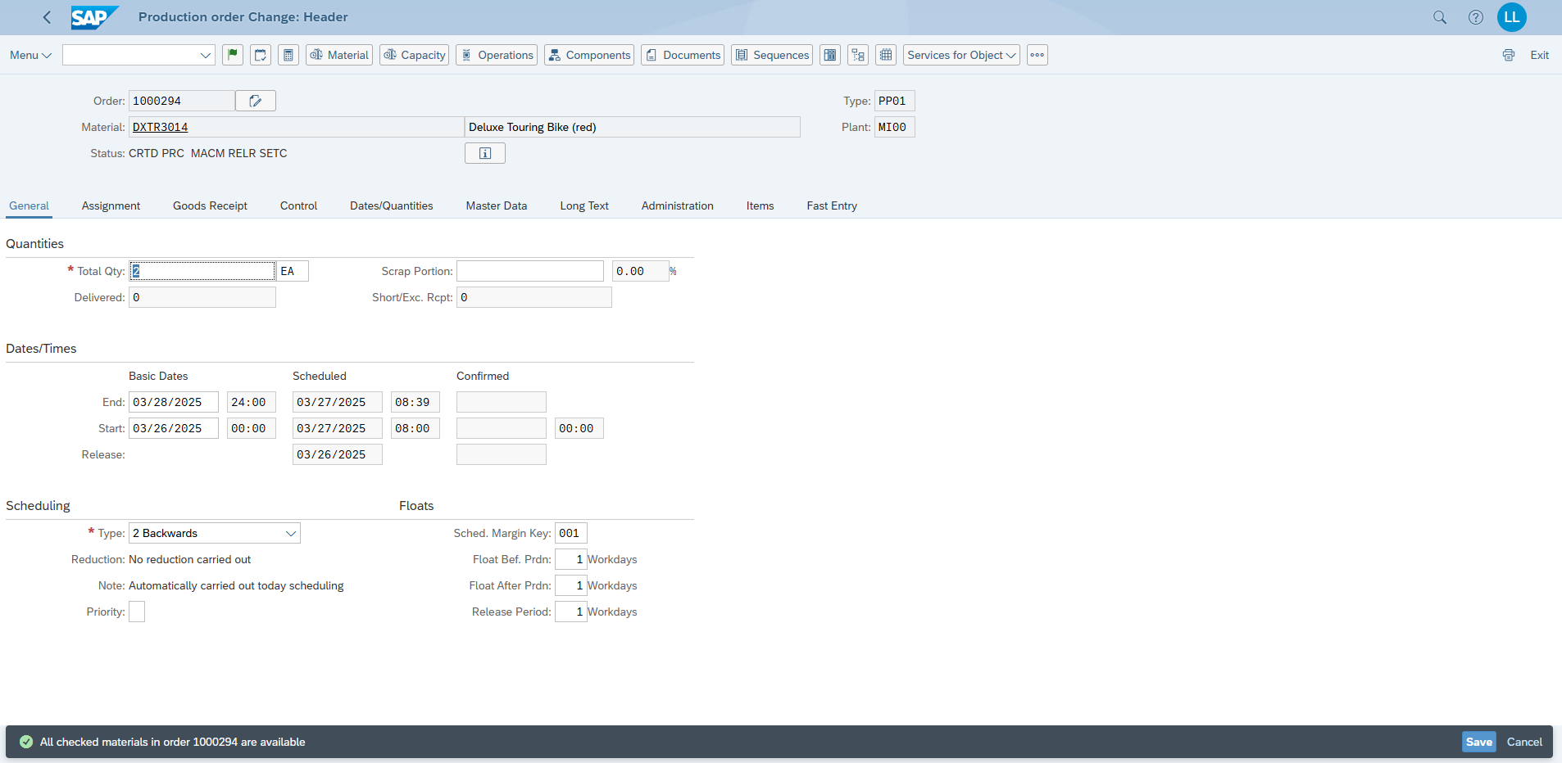

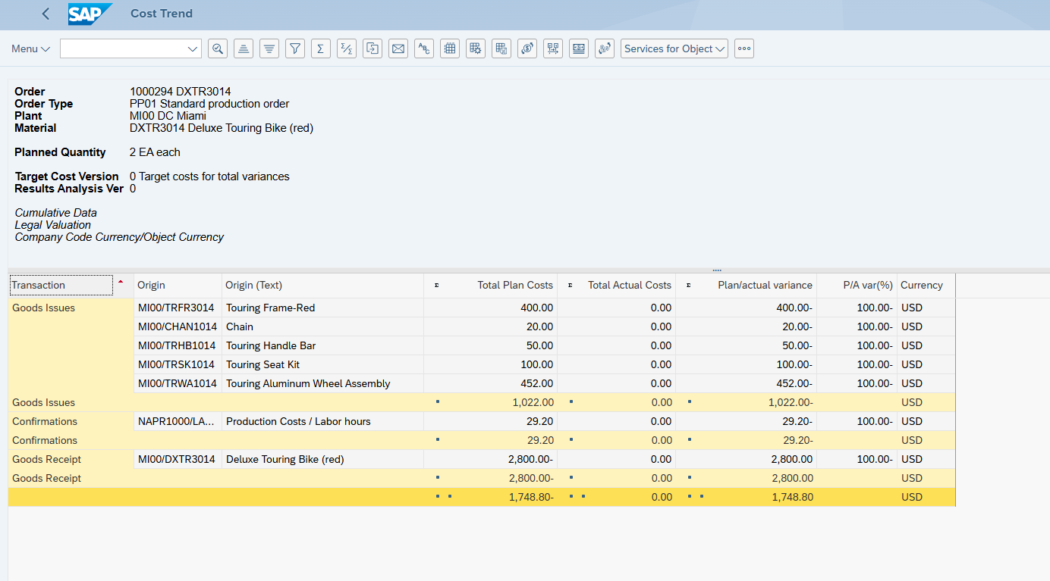

After Refresh

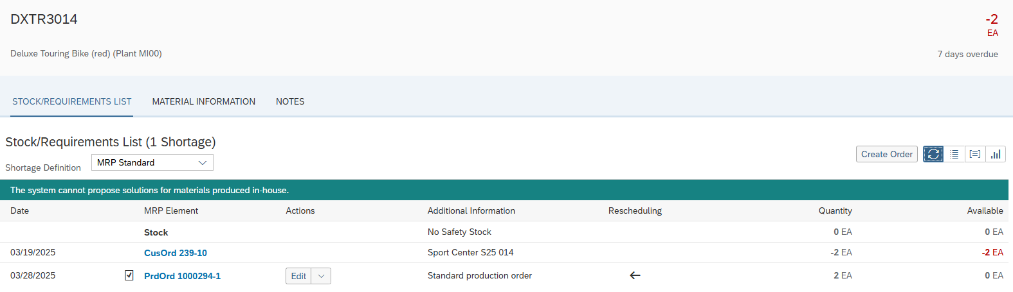

DXTR3014

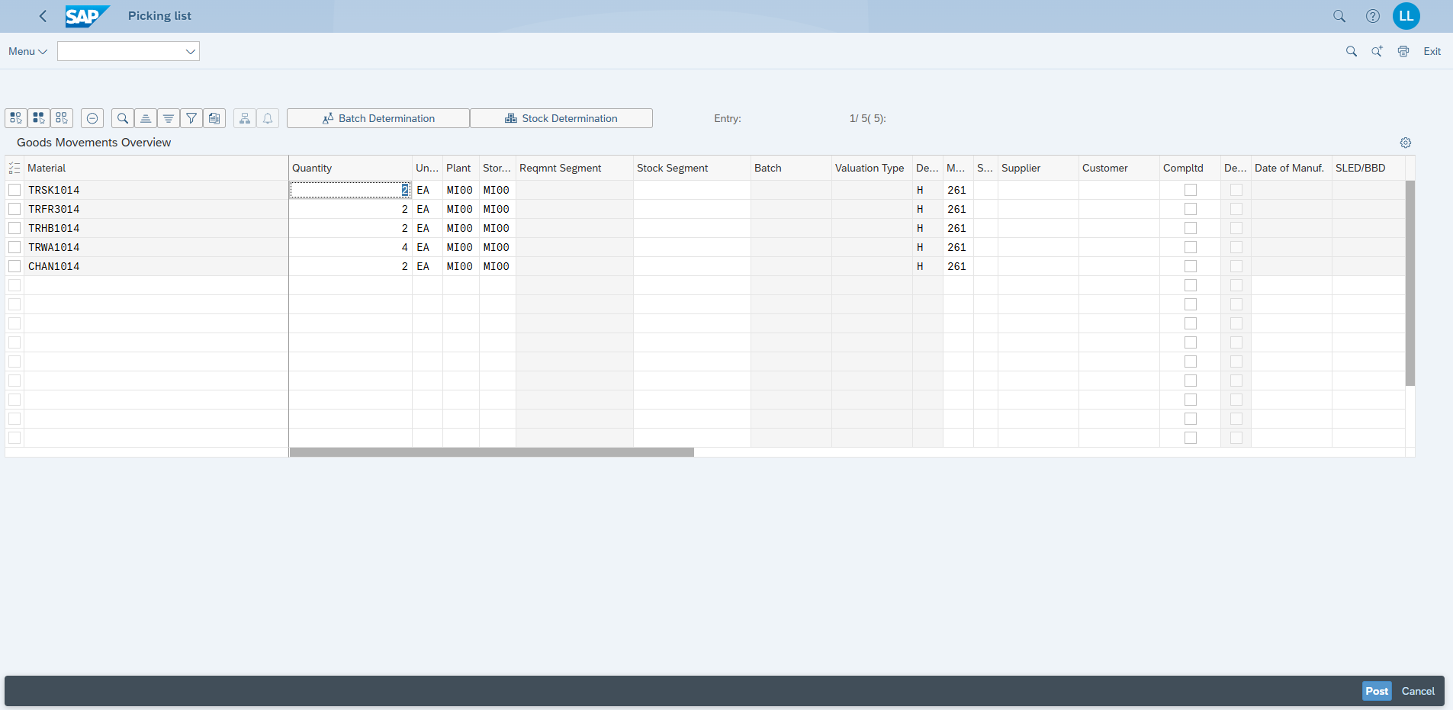

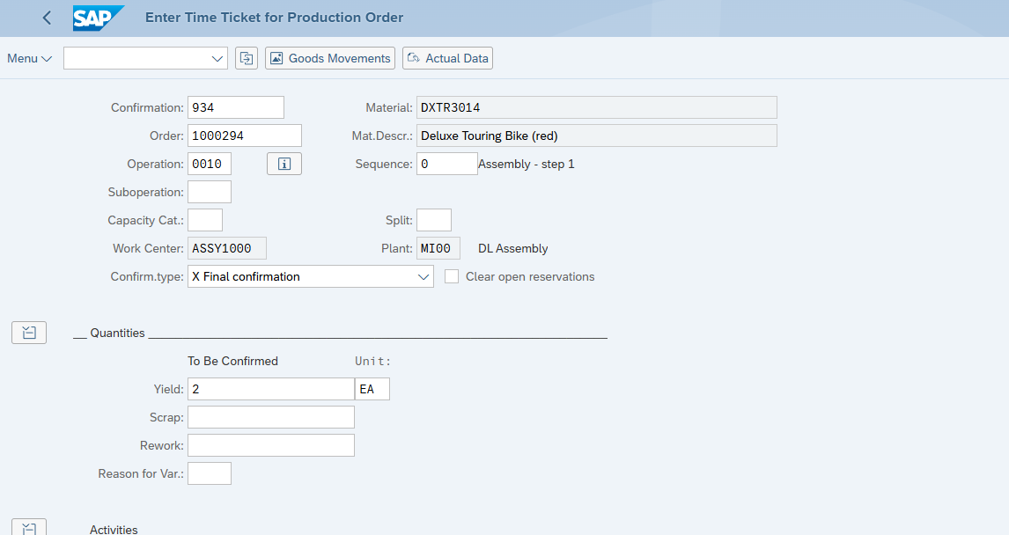

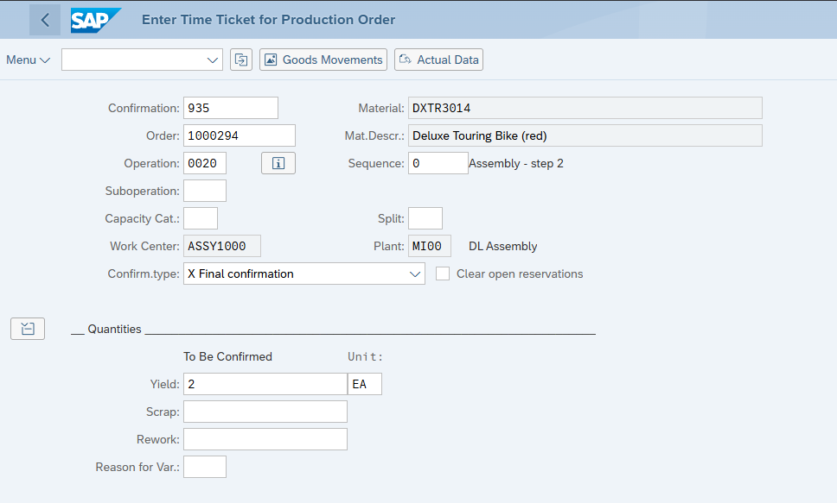

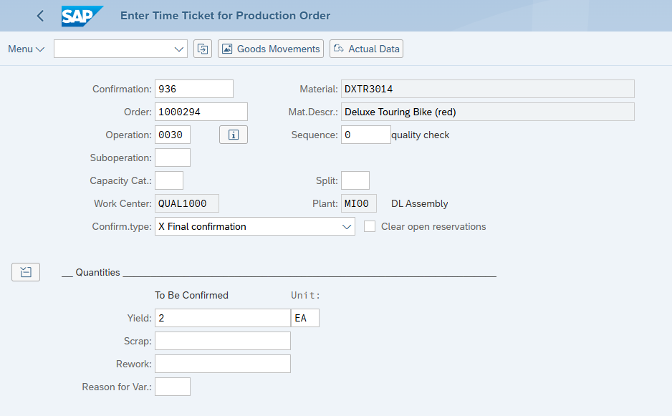

Manage Production Order

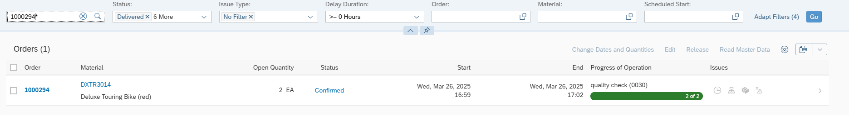

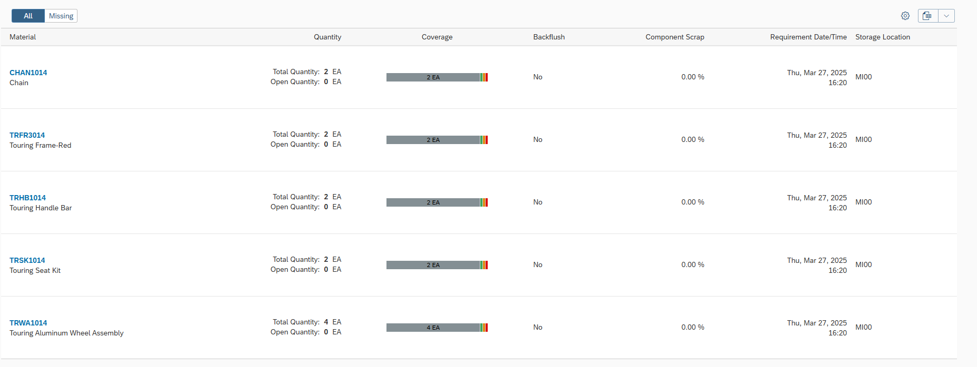

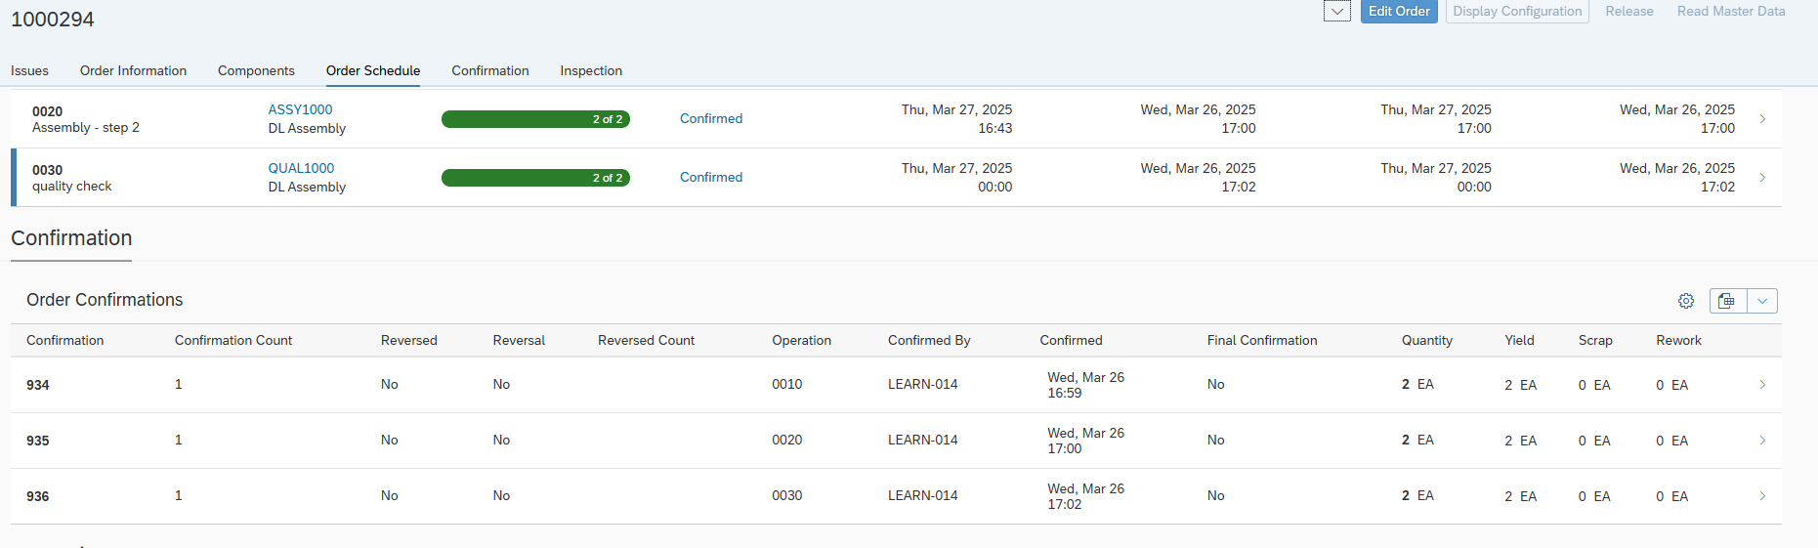

Finished Good as : Storage Location

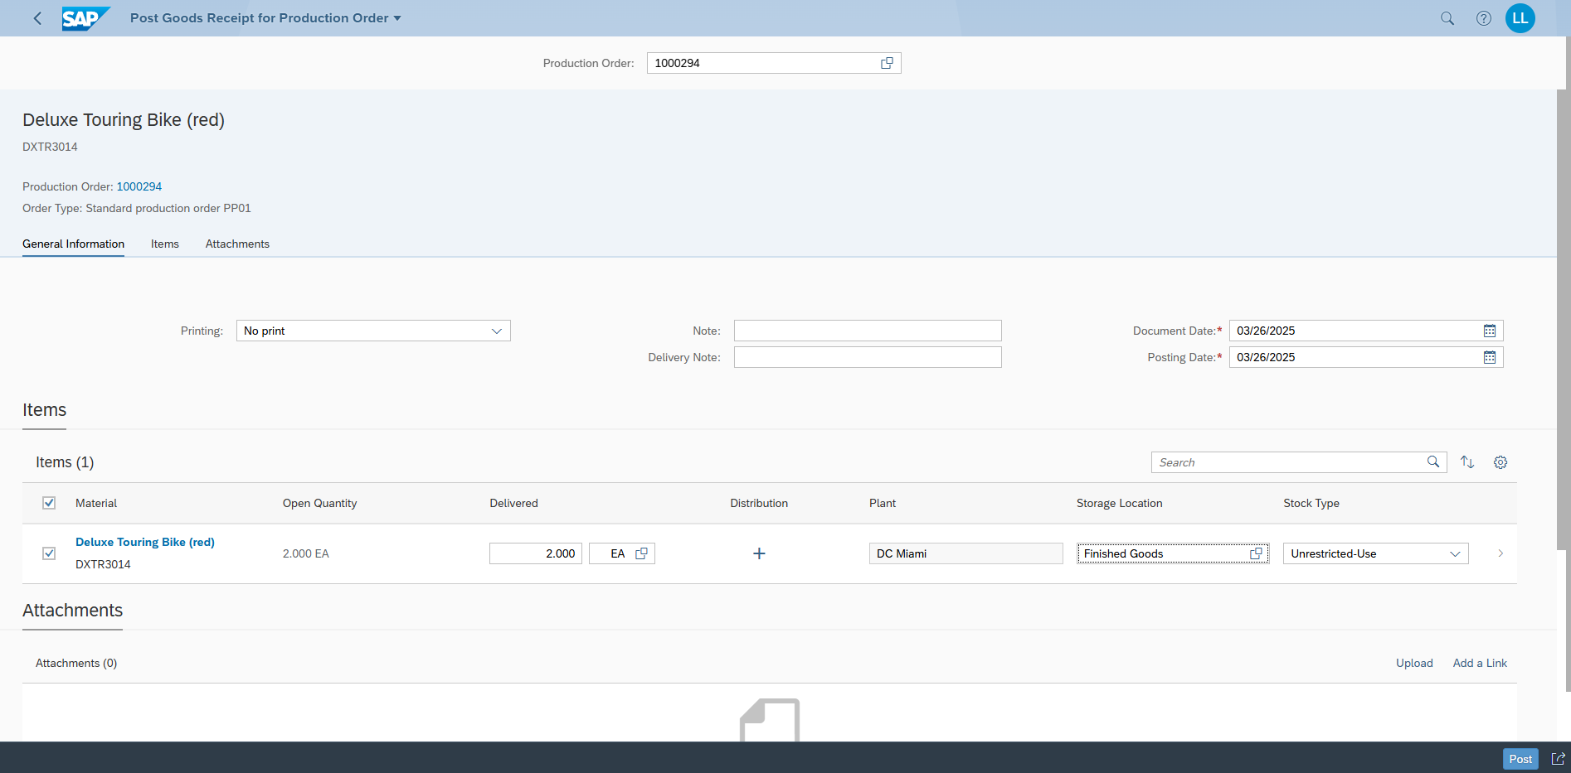

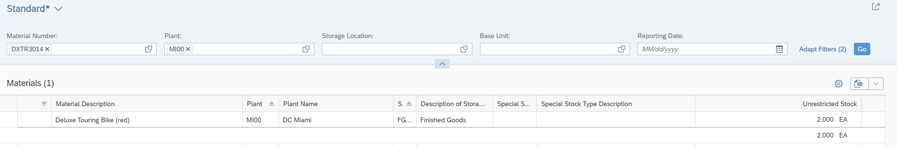

### Step 12: Delivery of goods to customer

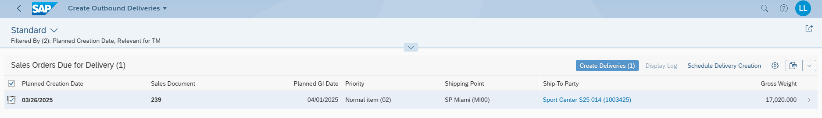

Number of outbound deliv.: 80000124

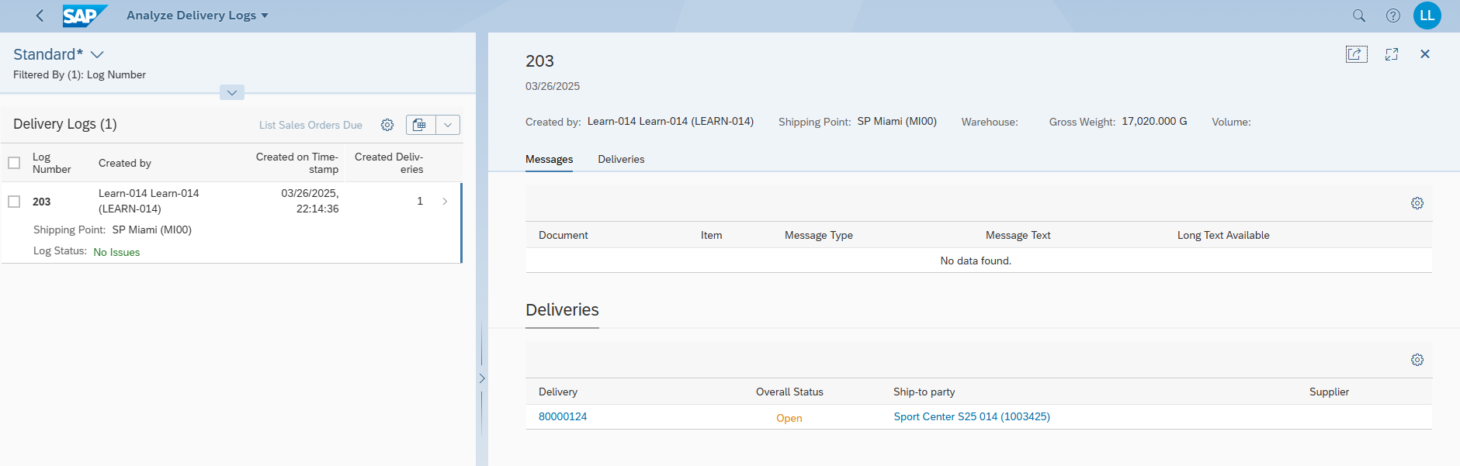



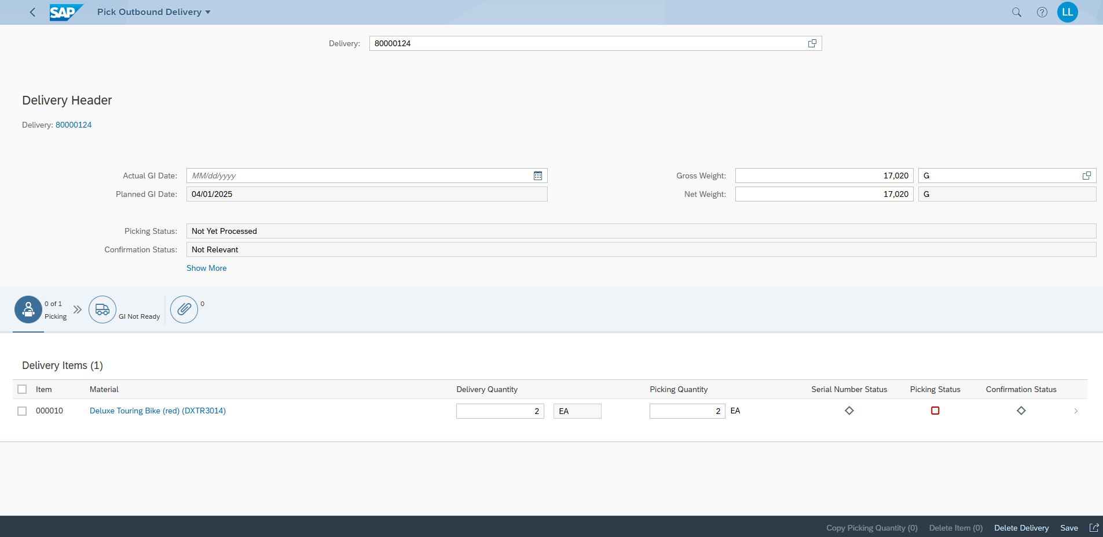

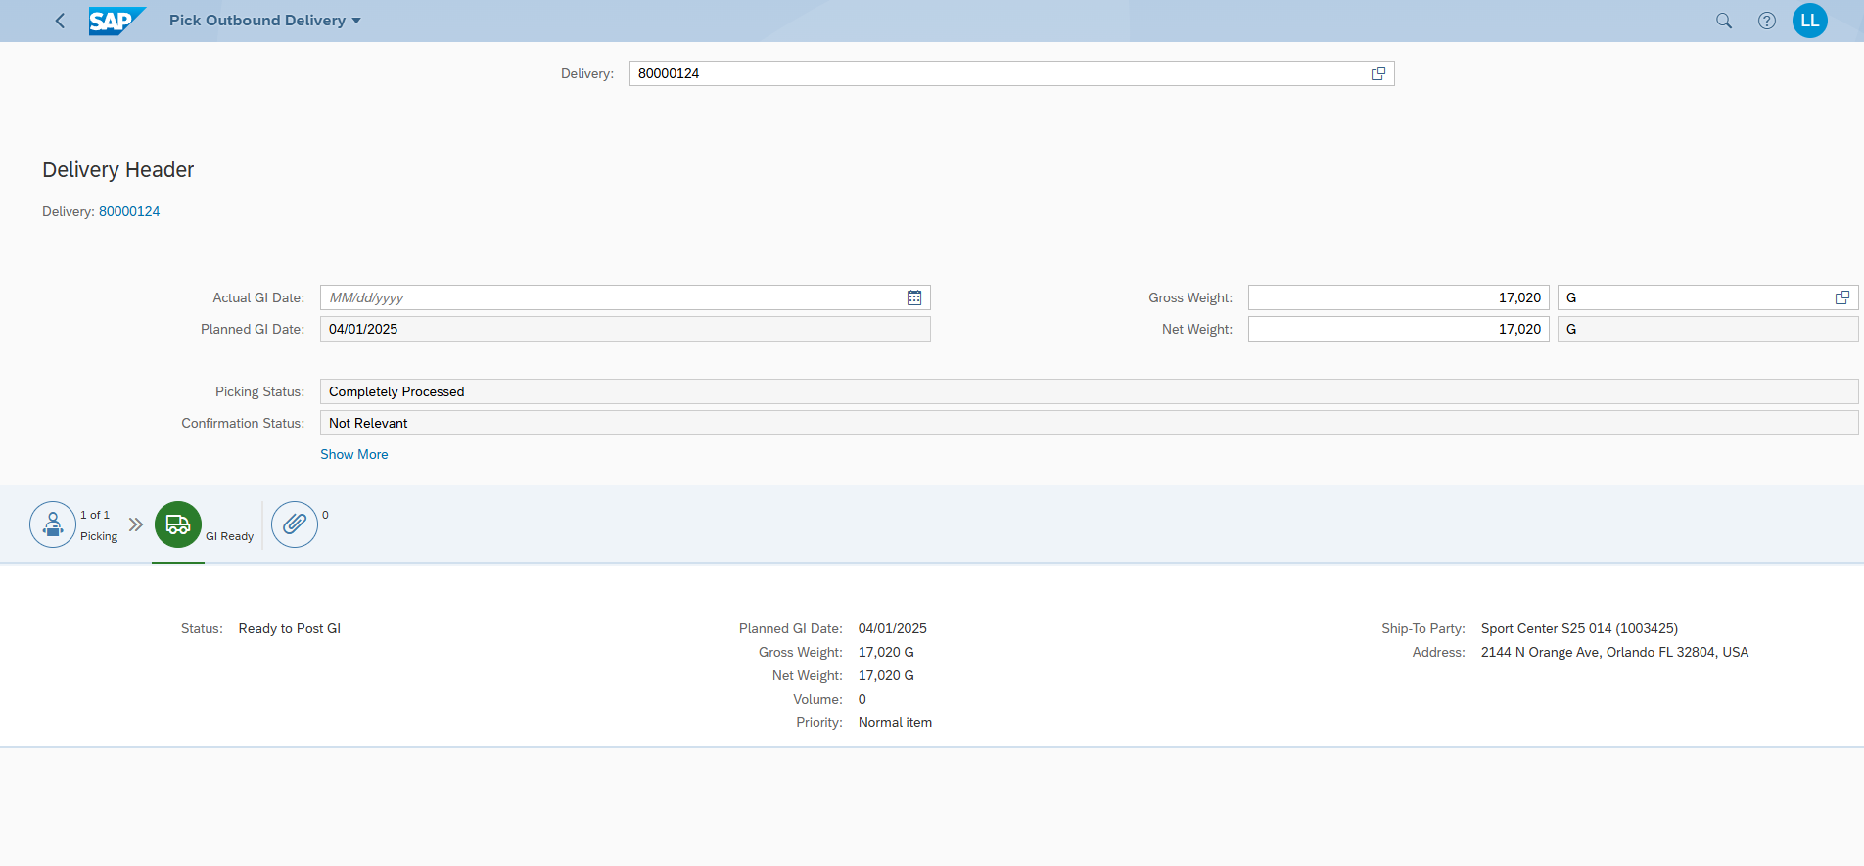

What can you see?

The Stock was reduced by 2.

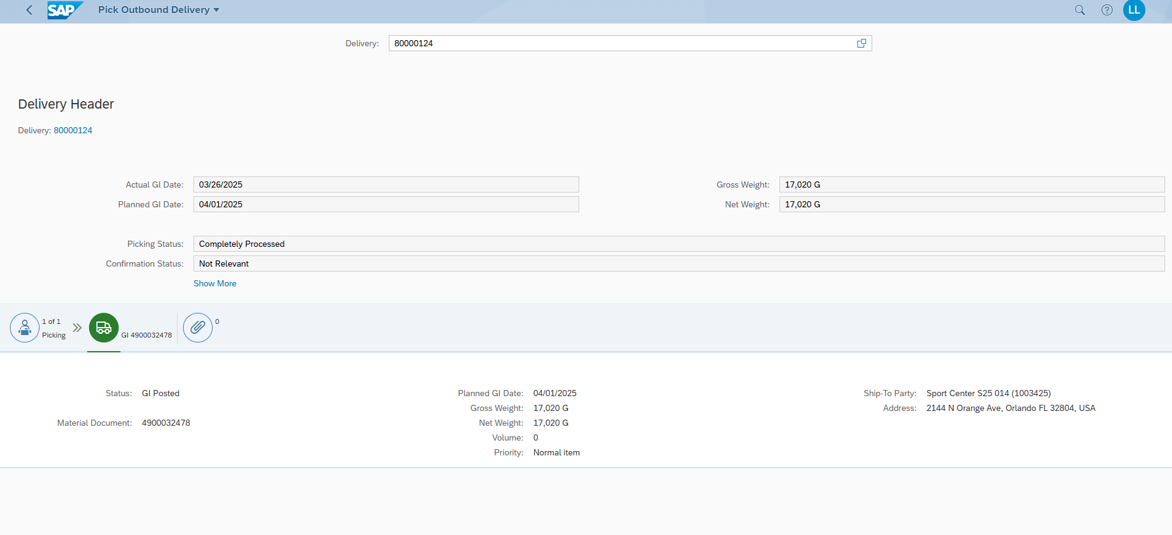

### Step 13: Create Billing Document for customer

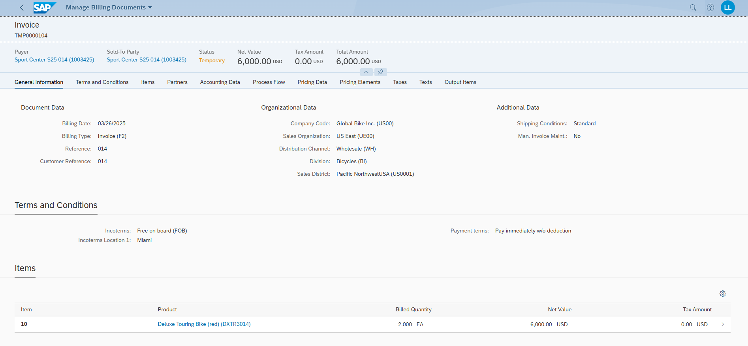

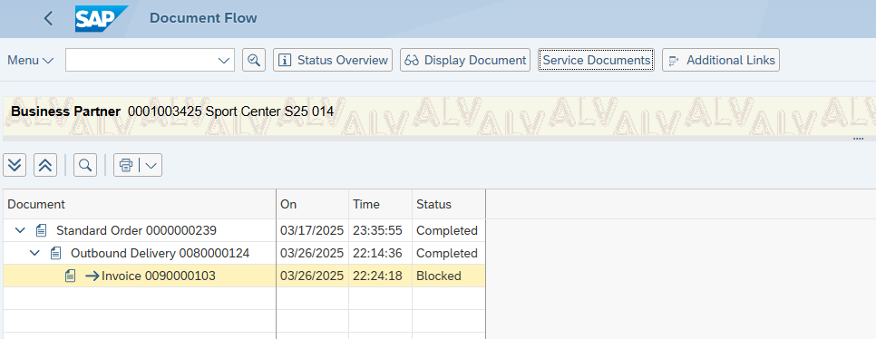

What can you see in the document flow?

Both Standard order and outbound delivery are finished and completed but th einvoice has status blocked which would likely mean issue like credit hold or missing approval.